**4 TESTING AND VALIDATION**

**4.1**  **INTRODUCTION**

In a software development project, errors can be introduced at any stage during development. Testing the capabilities of a system is a very important task. Users interested in getting their job done and test cases should be chosen to identify the system that will stop them from doing their job. Although errors such as seen corruption are irritating they are less disruptive than errors. It’s important that the system works under normal usage conditions than under occasional conditions that only arise with extreme data values.

**4.2 TESTING STEPS**

**4.2.1 Unit Testing**

Unit tests are written from a programmer’s perspective. They ensure that a particular method of a class successfully performs a set of specific tasks. Each test confirms that a method produces the expected output when given a known input. A series of stand-alone tests are conducted during unit testing. Each test examines an individual component that is new or has been modified. Unit tests focus on functionality and reliability. Unit testing is done in a test environment prior to the system integration. If a defect is discovered during a unit test, the severity of the defect will dictate whether or not it will be fixed before the module is approved.

**4.2.2 Integration Testing**

Integration testing examines all the components and modules that are new, changed, affected by the change, or needed to form a complete system. Integration testing requires the involvement of other systems and interface with other API s, s, external partners, etc.

It is the phase of software testing in which individual software modules are combined and tested as a group. It follows unit testing and proceeds with system testing. Integration testing takes in its input modules that have been tested, groups them in large aggregates, applies tests defined in an integration test plan without aggregates, and delivers as its output the integrated system ready for system testing.

**4.2.3 Validation**

Validation testing can be defined in many ways, but a simple definition is that the validation succeeds when the software functions in the manner that is expected by the client. After validation test has been conducted, one of the three possible conditions exists. The function or performance characteristics confirm to specifications and are accepted. The deviation from specification is uncovered and a deficiency list is created. Proposed system under consideration has been tested by using validation test and found it to be working satisfactorily.

**4.2.4 Output testing**

After performing the validation, the next step is output testing of the proposed system, since no system could be useful if it does not produce the required output in a specific format. The output format on the screen is found to be correct. The format was designed in the system design time according to the user needs. For the hard copy also, the output comes as per the specified requirements by the user. Hence output testing did not result in any correction for the system

**4.2.3 User acceptance testing**

Acceptance testing is the level of software testing where a system is tested for acceptability. It is a formal testing with respect to other needs, requirements conducted to determine whether or not a system satisfies an acceptance criterion and to enable the users or others unauthorized to determine whether or not to accept a system.

**4.3 Test Cases**

**4.3.1 Sign up form:**

|  |  |  |  |
| --- | --- | --- | --- |
| **Test Case ID** | **Test Condition** | **Expected Output** | **Result** |
| 1 | If all field empty | Fill all the credentials | Success |
| 2 | If full name field empty | Please enter your full name | Success |
| 3 | If username field empty | Please enter your user name | Success |
| 4 | If email field empty | Please enter your email address | Success |
| 5 | If password field empty | Please enter a password | Success |
| 6 | If password confirm field empty | Please confirm your password | Success |
| 7 | If full name field consist number/special characters | Only alphabets and whitespaces are allowed | Success |
| 8 | If username field consist of less than 4 or greater than 15 characters | Username requires  4 – 15 characters | Success |
| 9 | If user name field consist number/special characters/whitespace/uppercase | Only lowercase letters are allowed | Success |
| 10 | If user name field consist of existing username | Username already taken |  |
| 11 | If email field consist of invalid email | Invalid email format | Success |
| 12 | If email field consisting of existing email | Account already exist for this email | Success |
| 13 | If password field consist of less than 8 characters | Minimum 8 characters required | Success |
| 14 | If password field does not contain combination of number and letter | Combination of alphabets and numbers required | Success |
| 15 | If confirm password field does not match password field | Password entered does not match | Success |
| 16 | If all credentials are valid | Account created successfully and redirect to login page. | Success |

**Sign up page:**

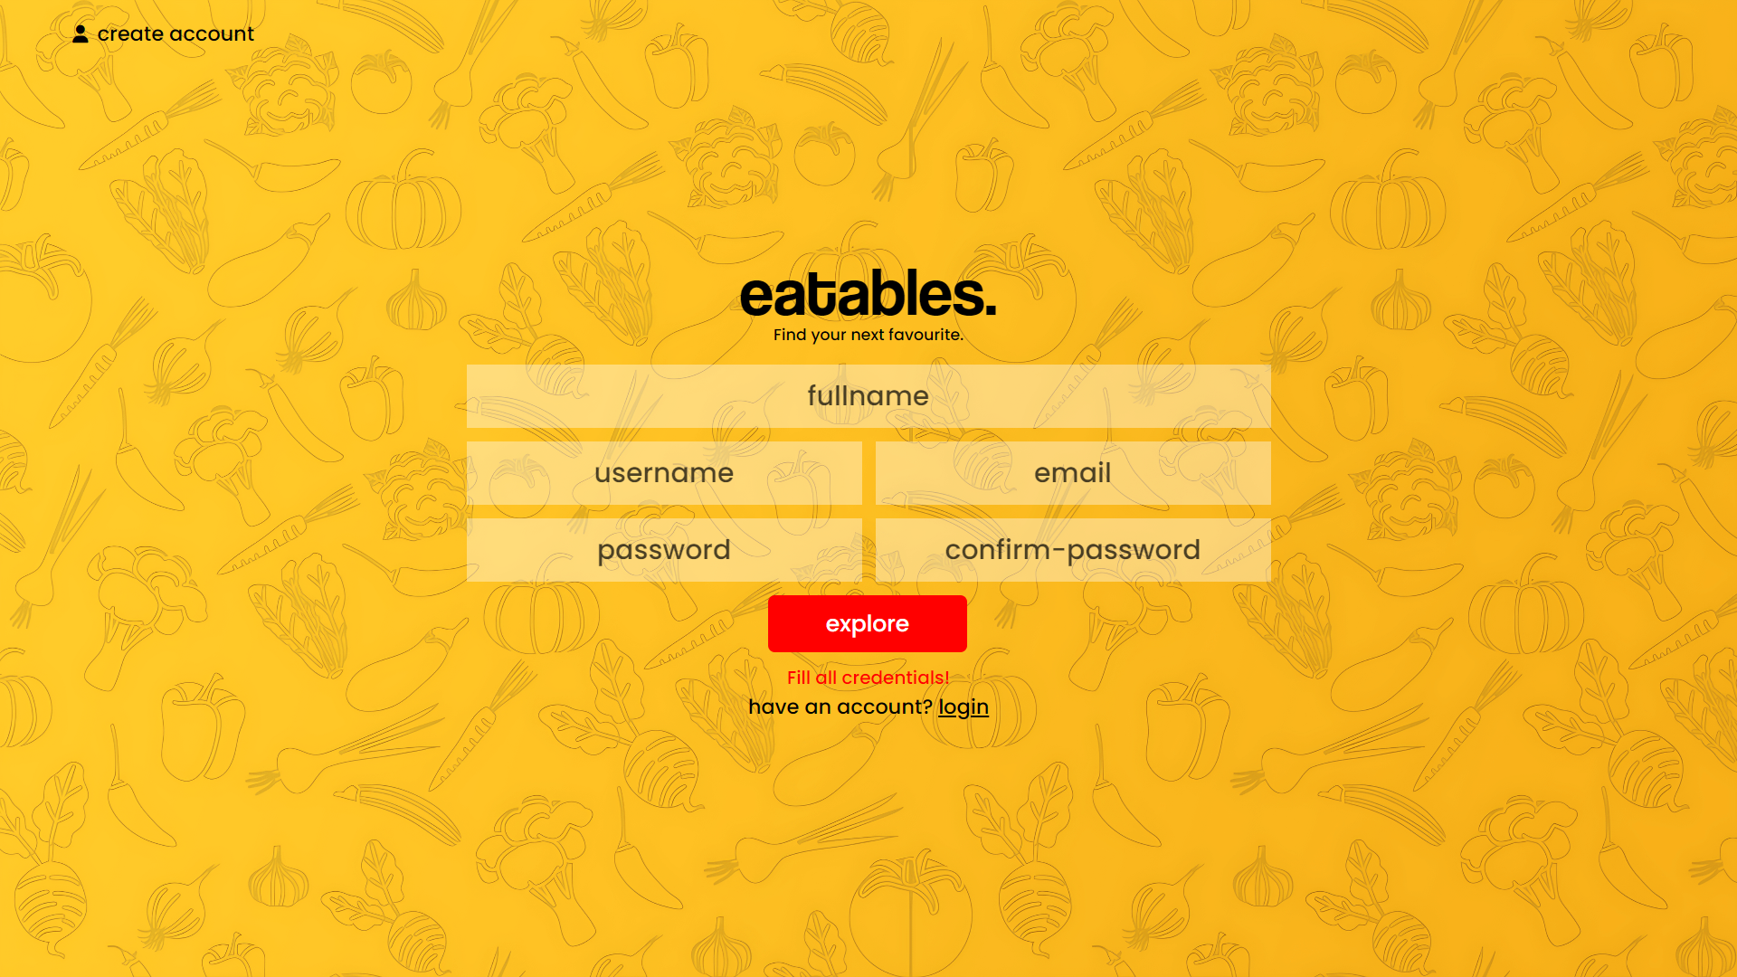

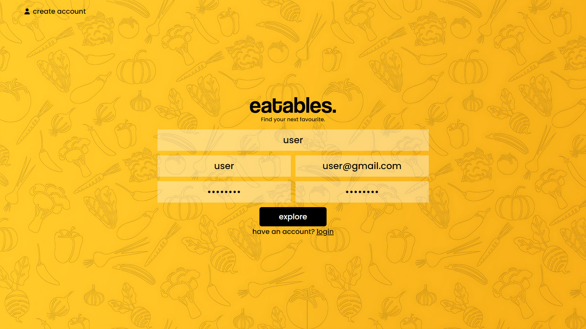

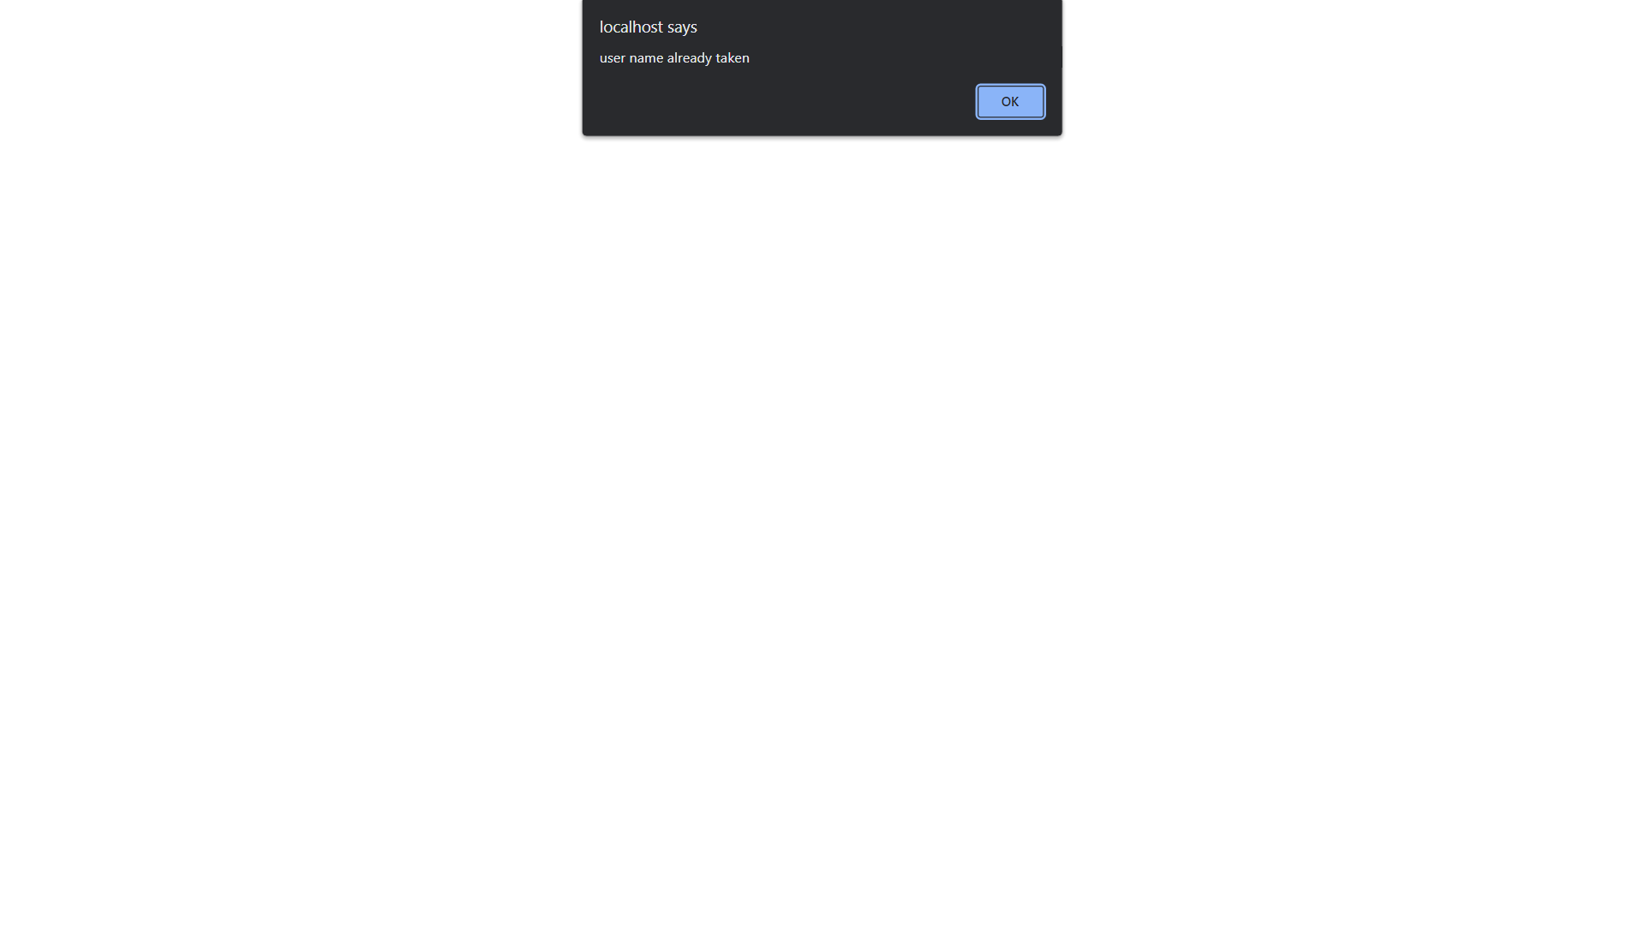

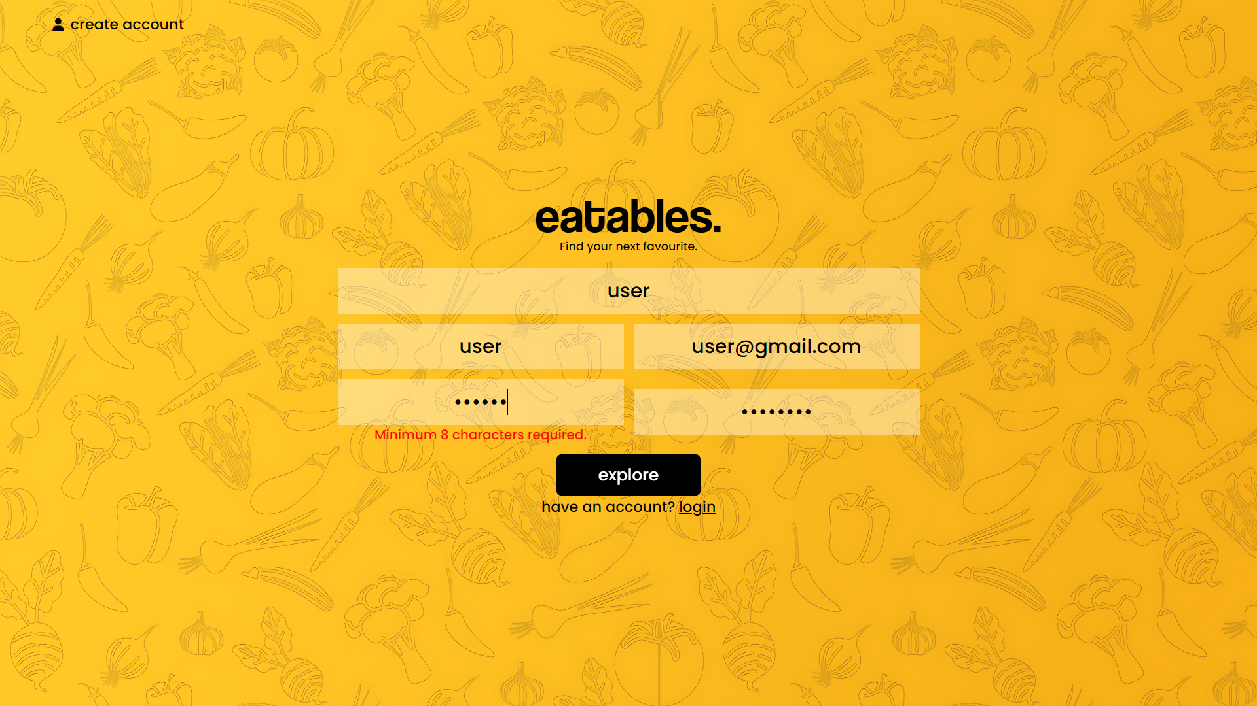

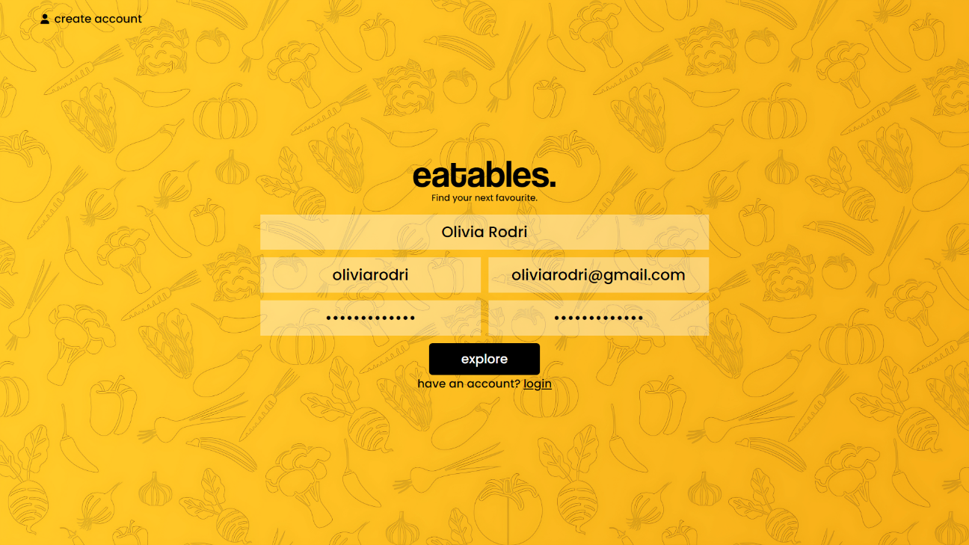

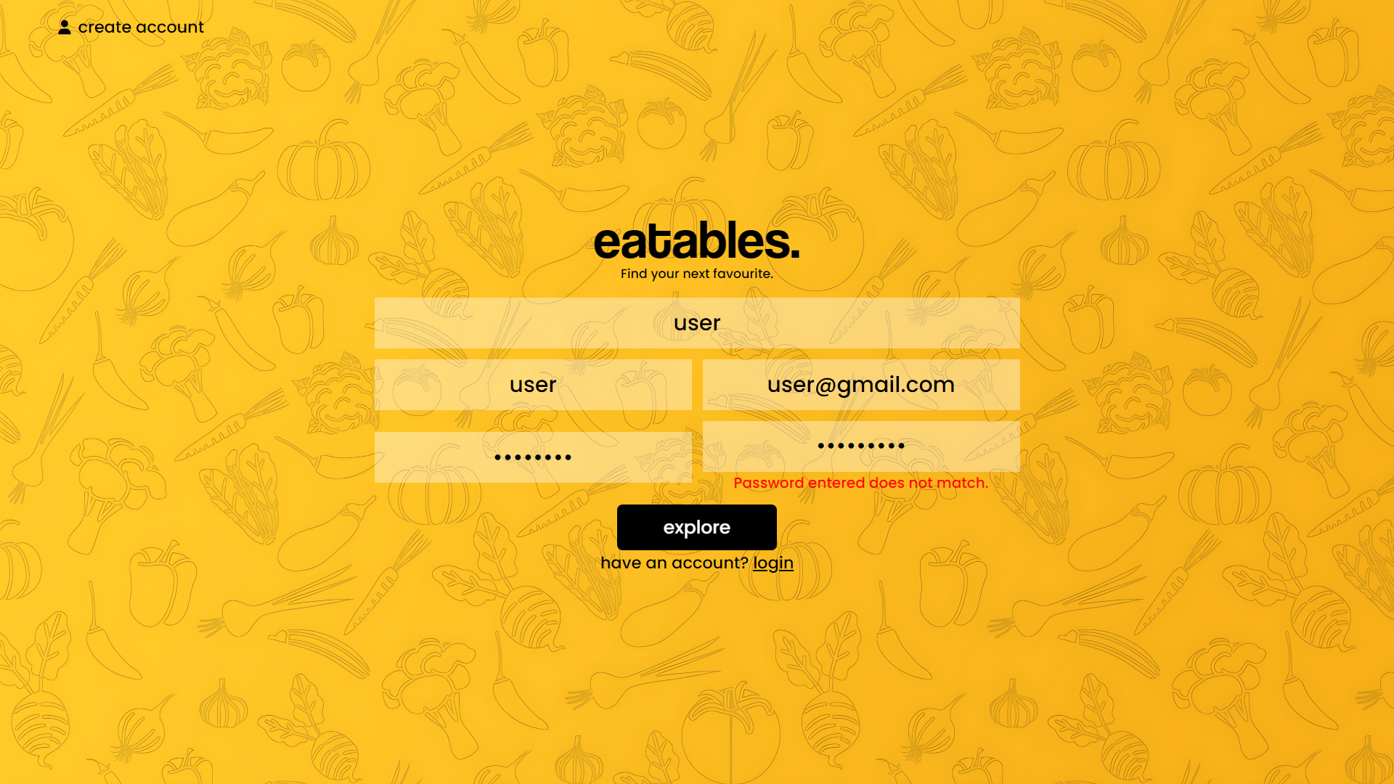

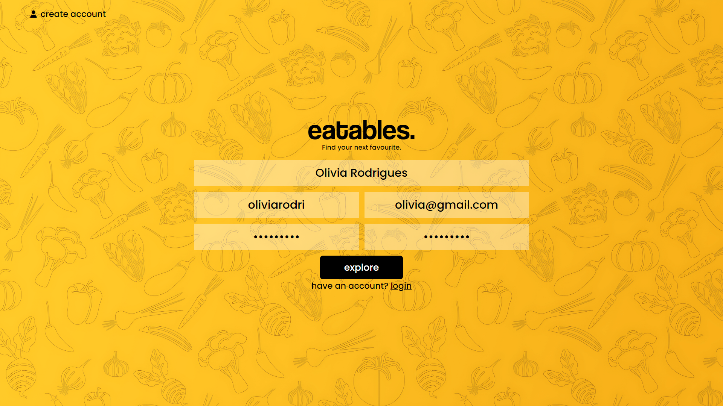

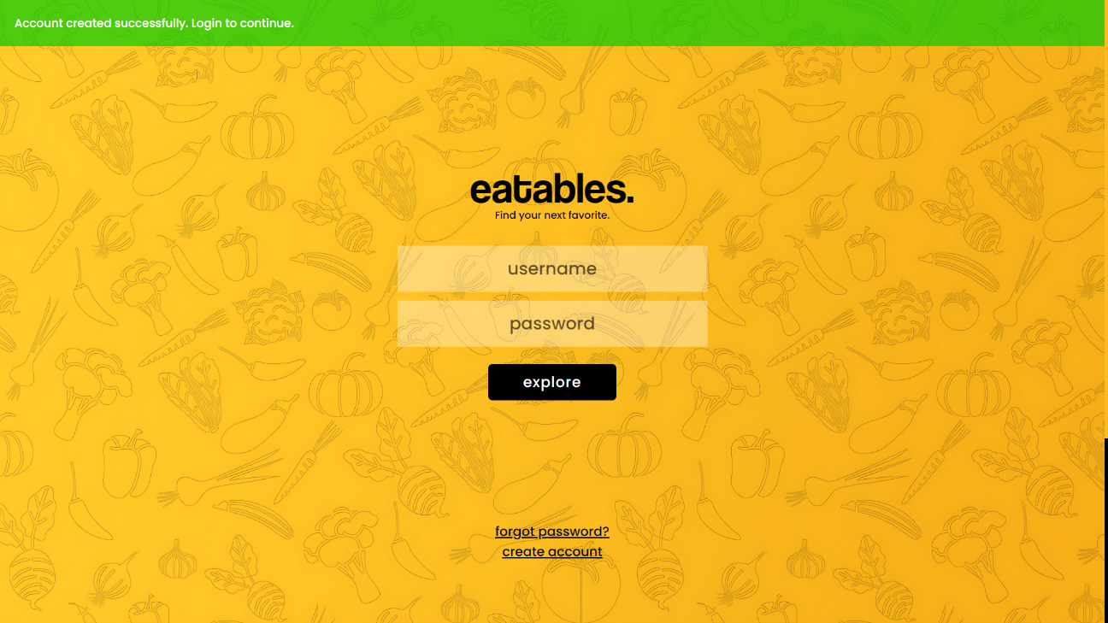

**4.3.2 Login form:**

|  |  |  |  |
| --- | --- | --- | --- |
| **Test Case ID** | **Test Condition** | **Expected Output** | **Result** |
| 1 | If username field empty | Please fill out this field | Success |
| 2 | If password field empty | Please fill out this field | Success |
| 3 | If inputs wrong username | User not found | Success |
| 4 | If inputs wrong password | Password incorrect | Success |
| 5 | If user clicks on forgot password | Redirects to reset password page | Success |
| 6 | If username and password are valid for user | Redirects to user home page | Success |
| 7 | If username and password are valid for admin | Redirects to admin profile page | Success |

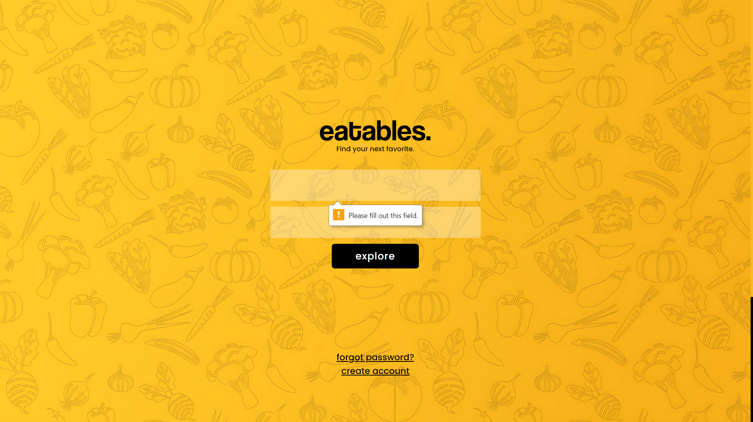

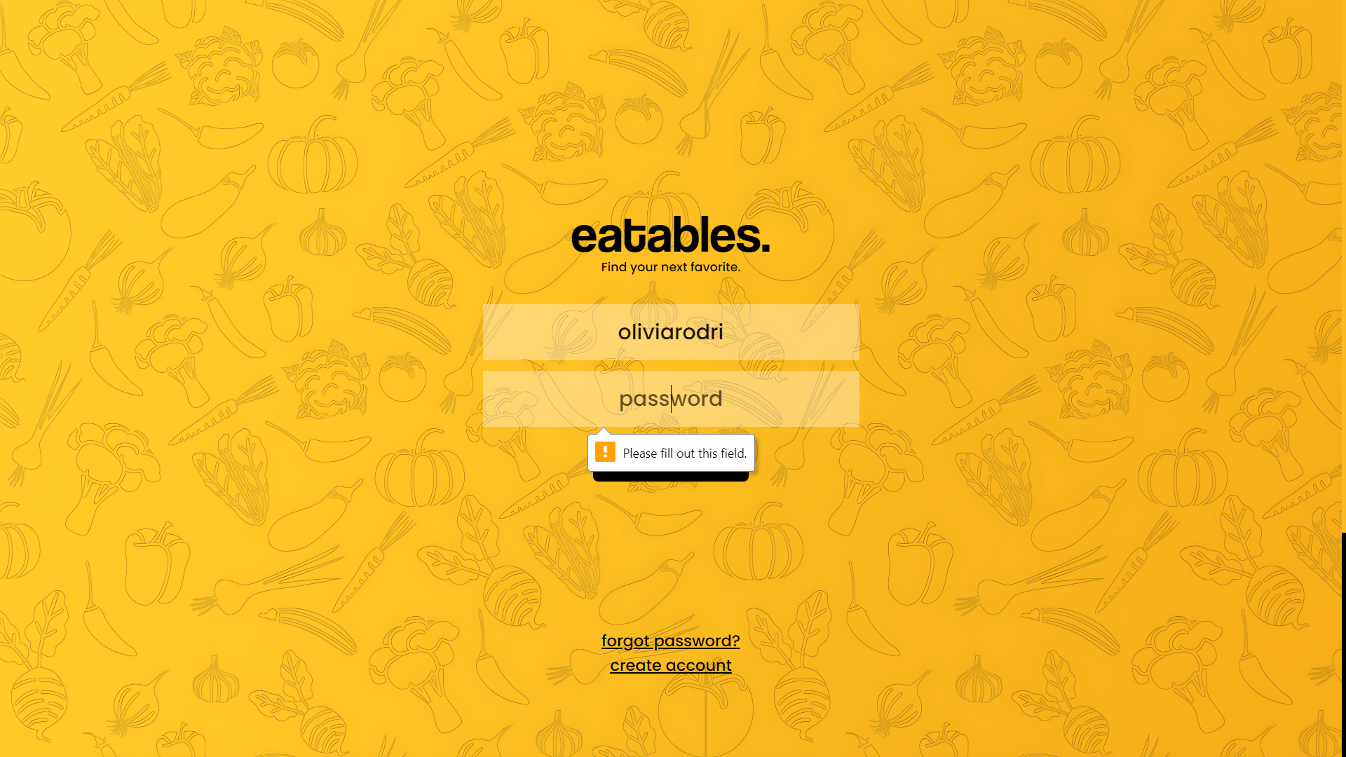

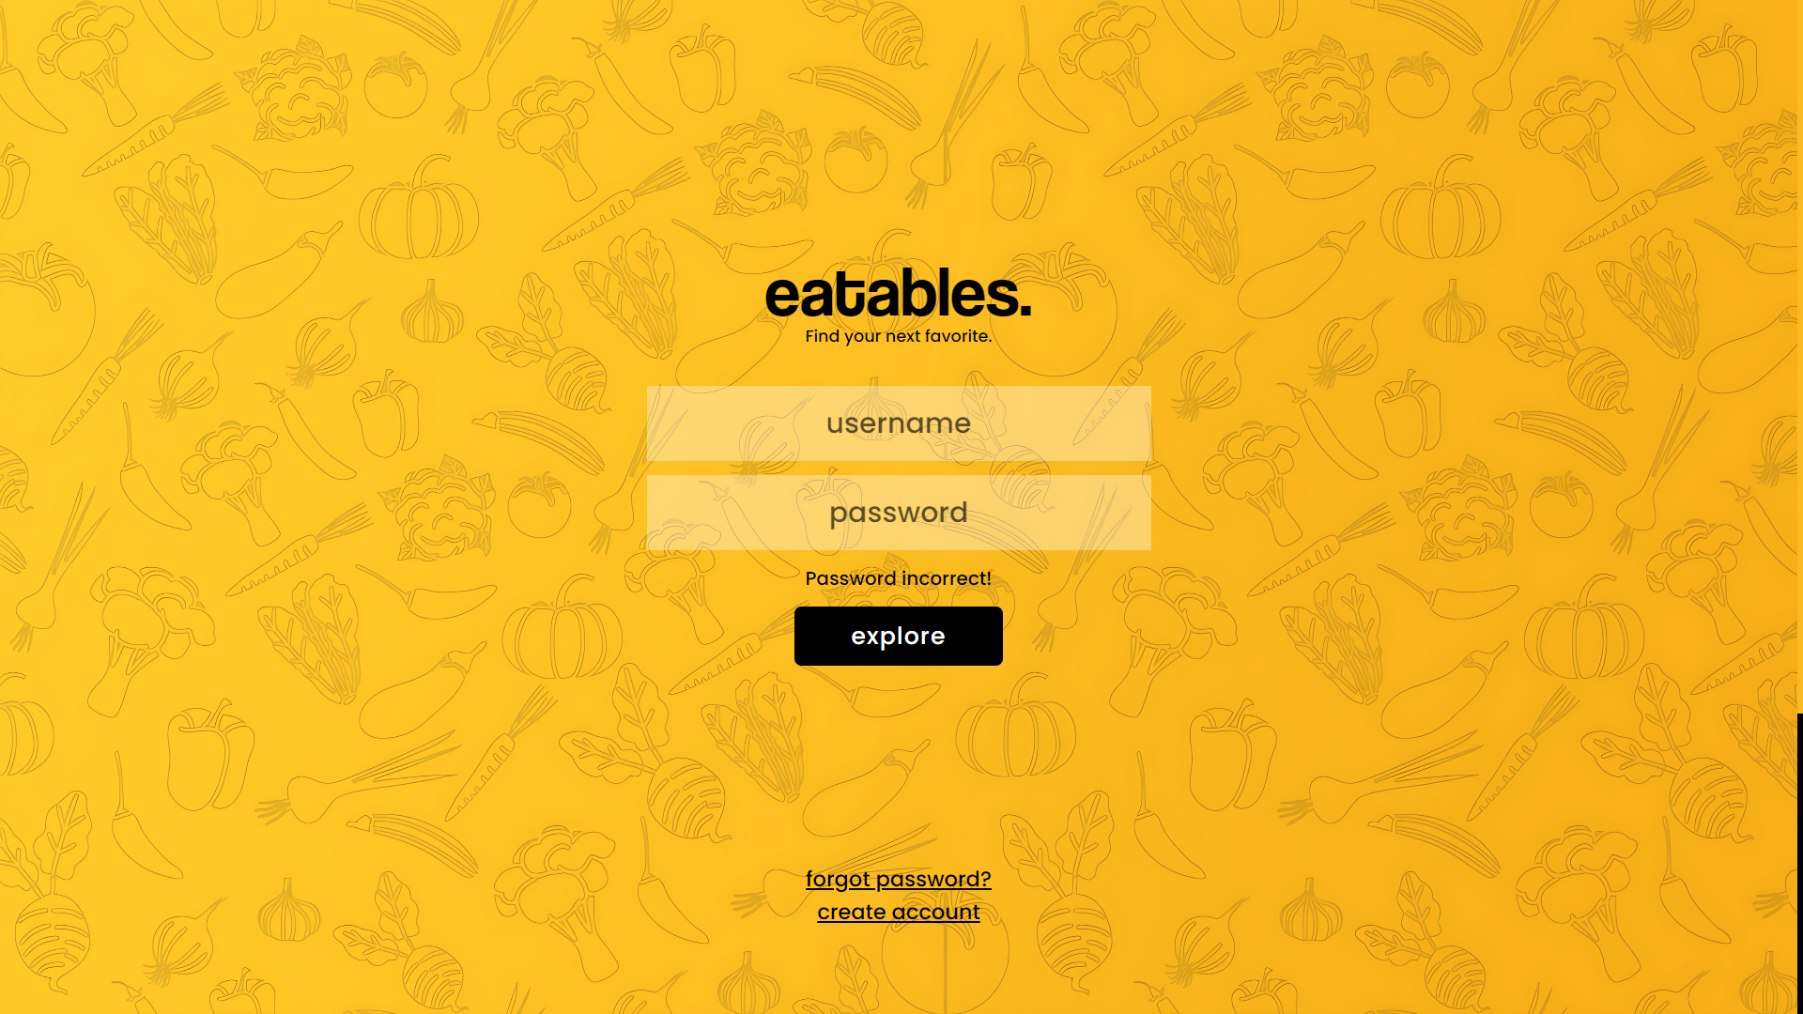

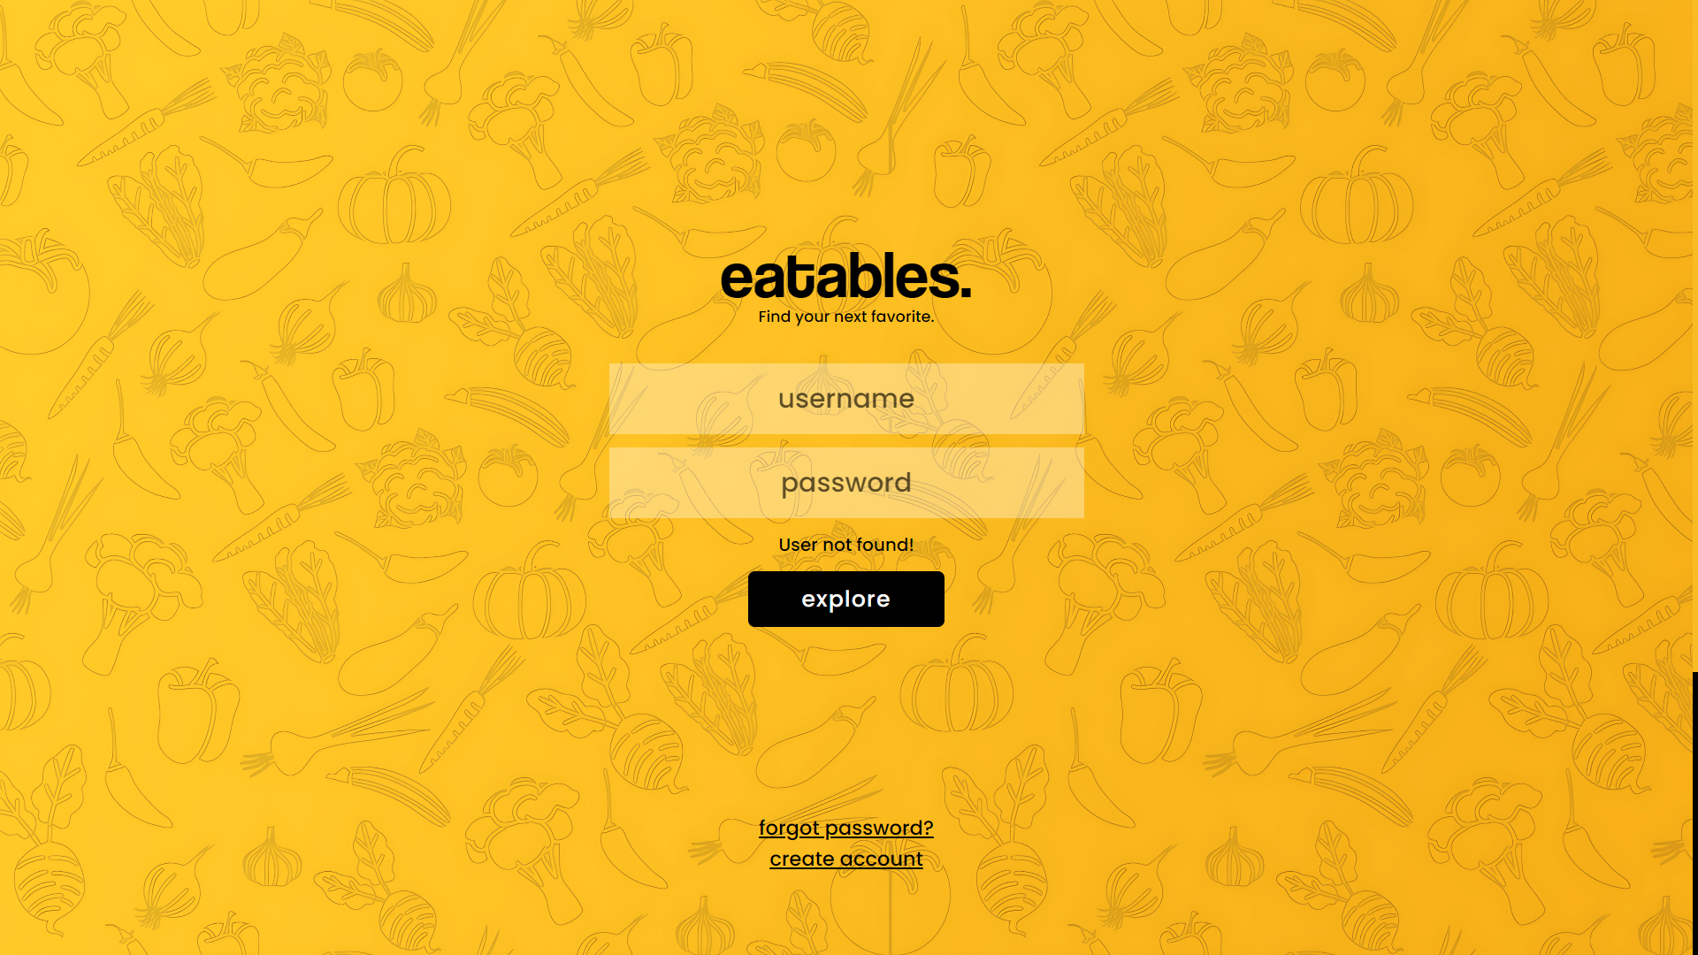

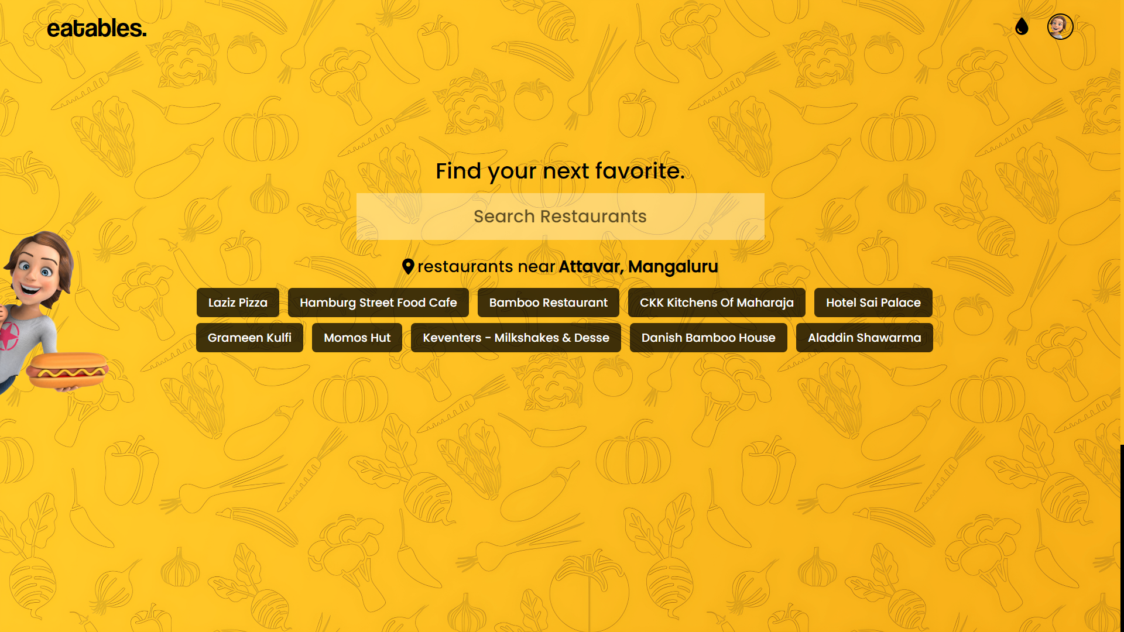

**4.3.3 Home page:**

|  |  |  |  |
| --- | --- | --- | --- |
| **Test Case ID** | **Test Condition** | **Expected Output** | **Result** |
| 1 | If user types restaurant name in search box. | Displays similar  restaurant names under search box | Success |
| 2 | If user clicks on eatables logo. | Page refreshes | Success |
| 3 | If user clicks on Drops icon | Redirects to Drops page | Success |
| 4 | If user clicks on profile icon | Redirects to user profile page | Success |
| 5 | If user chooses a restaurant name | Redirects to item details page | Success |
| 6 | If user click on assistant | Opens filter window | Success |
| 7 | If user applies price filter | Displays items based on the price | Success |
| 8 | If user clicks on Submit restaurant | Redirects to restaurant suggestion page | Success |

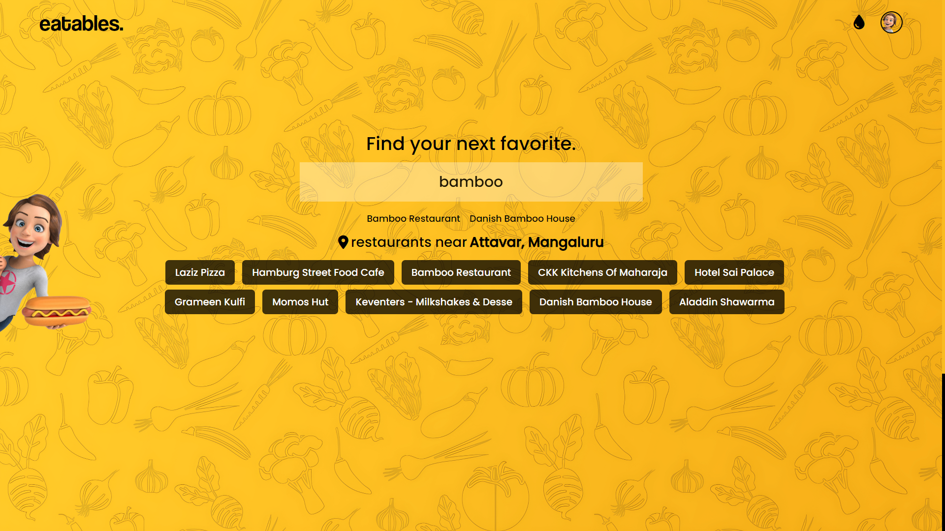



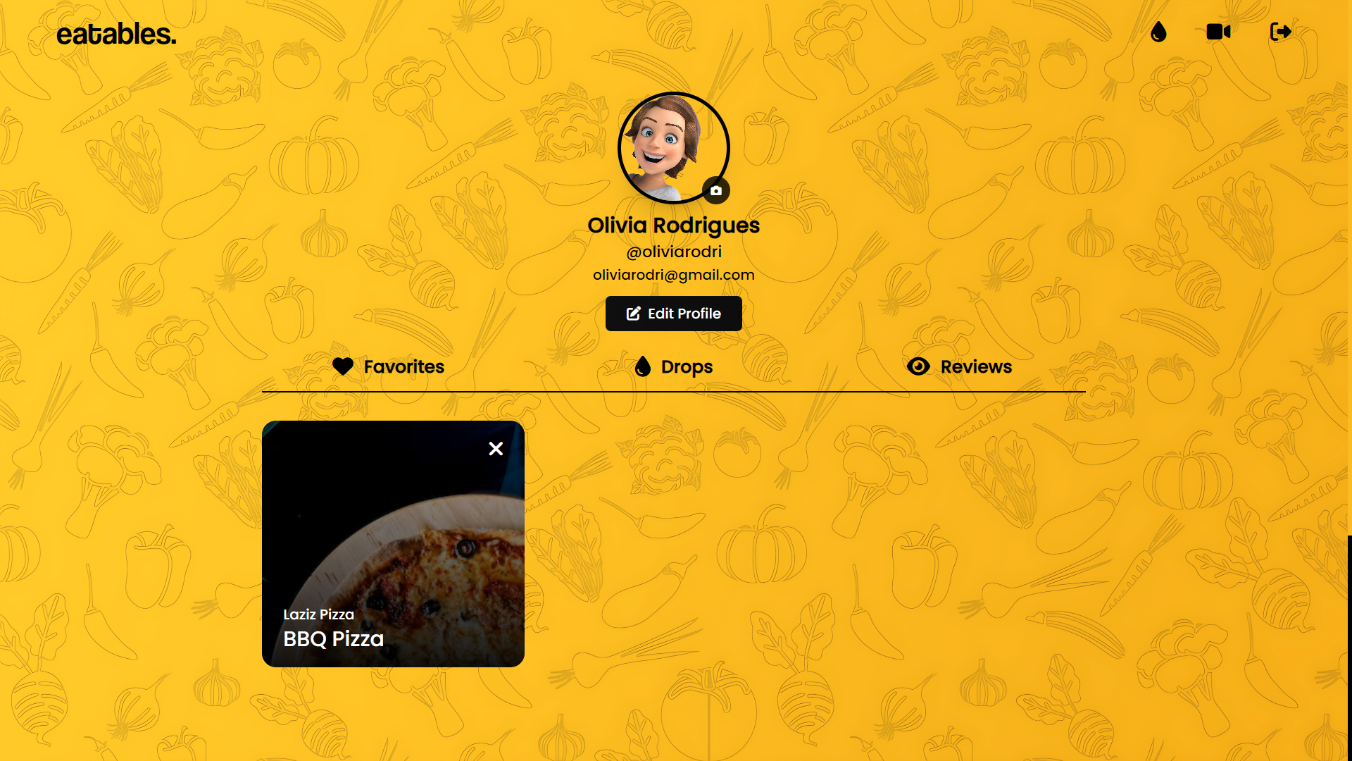

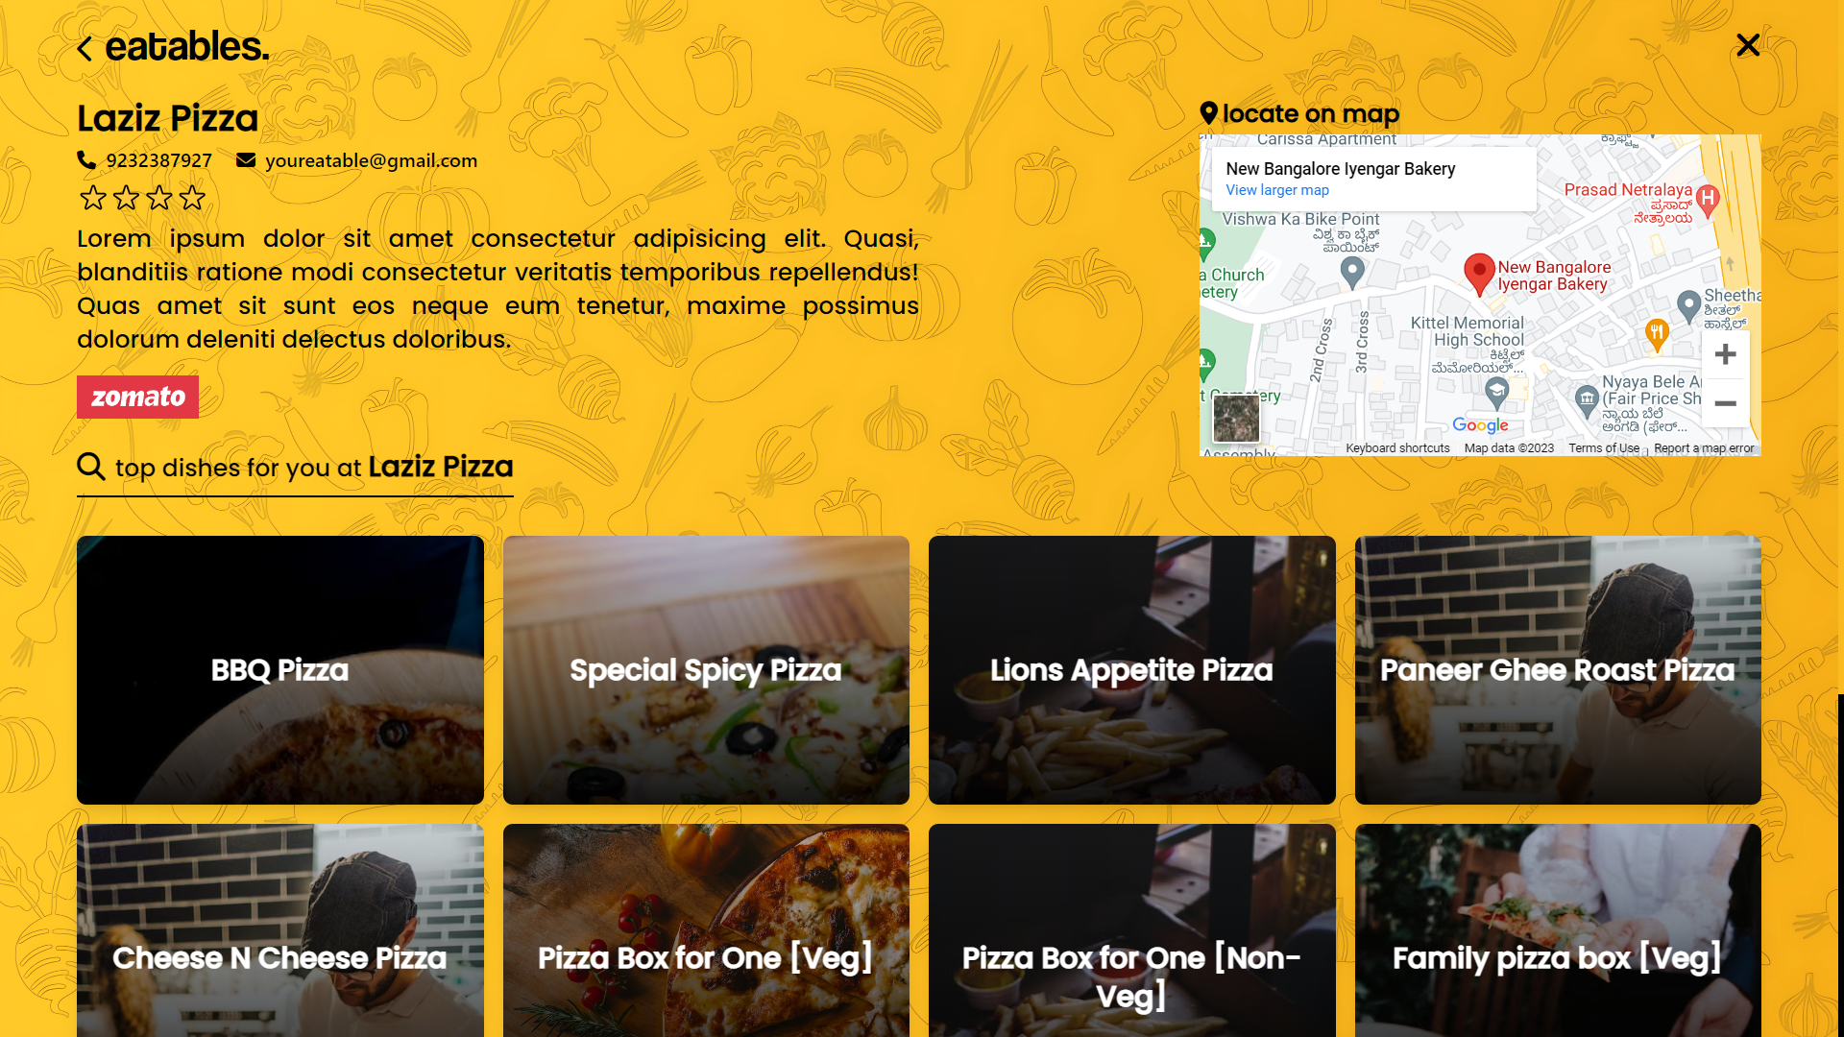

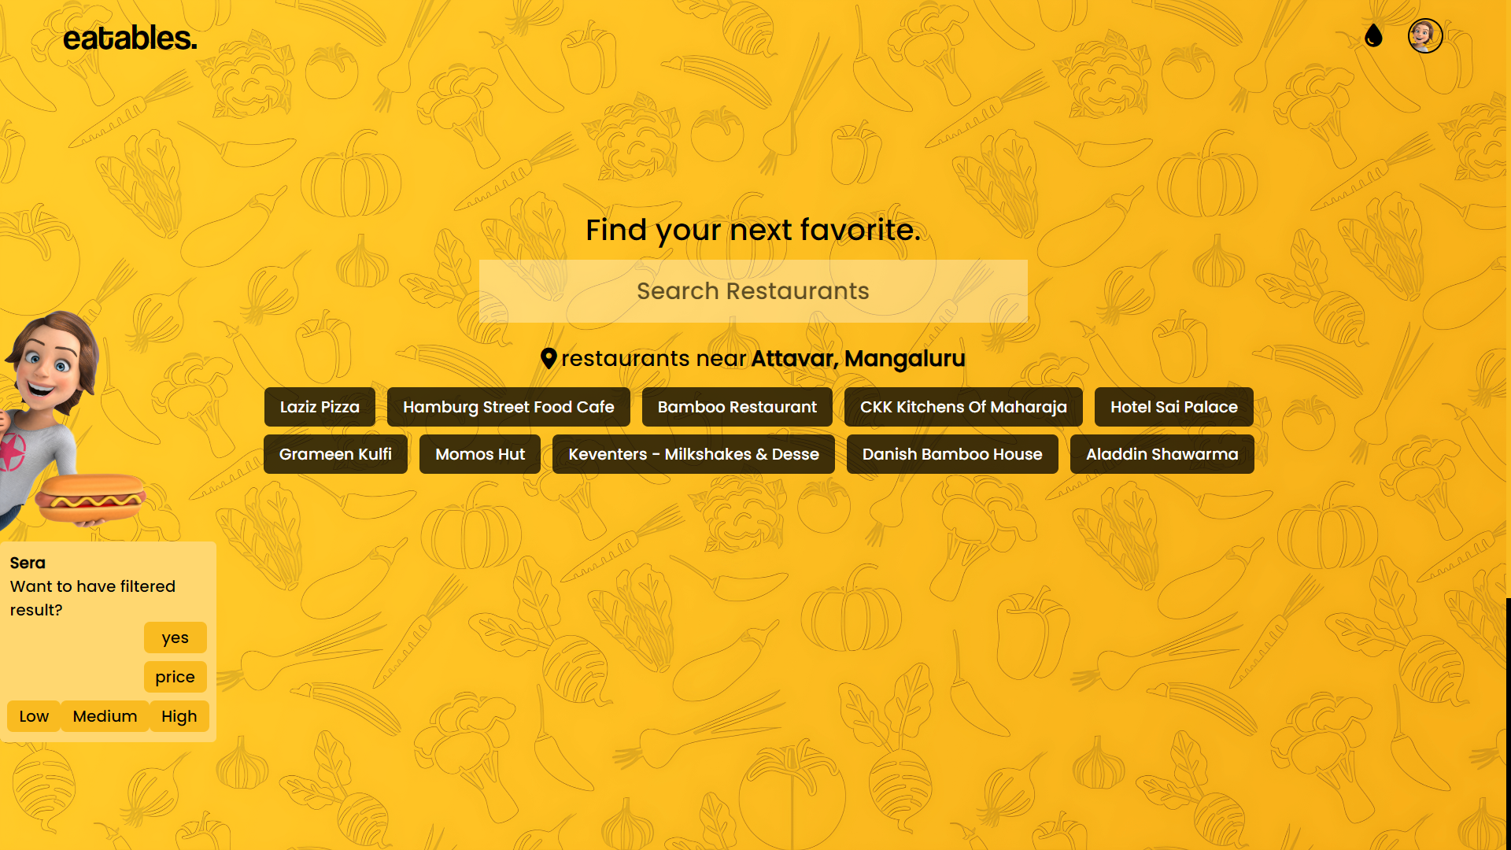

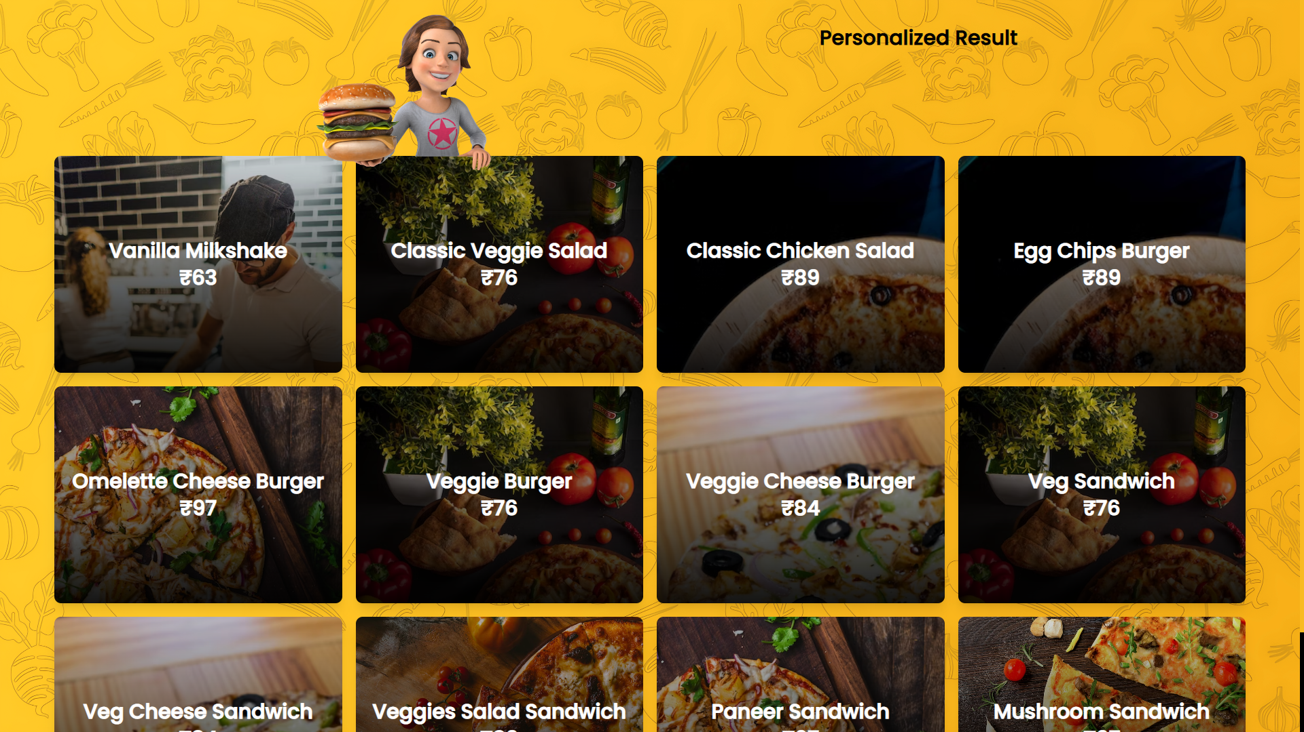

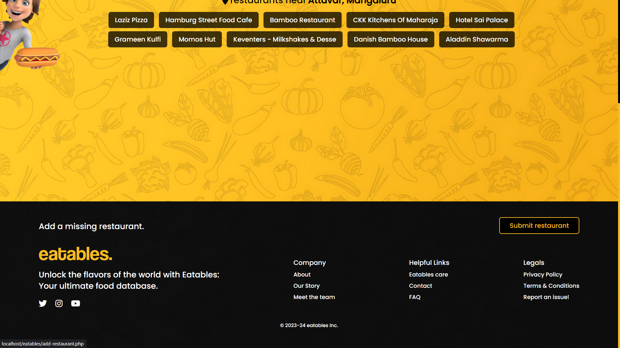

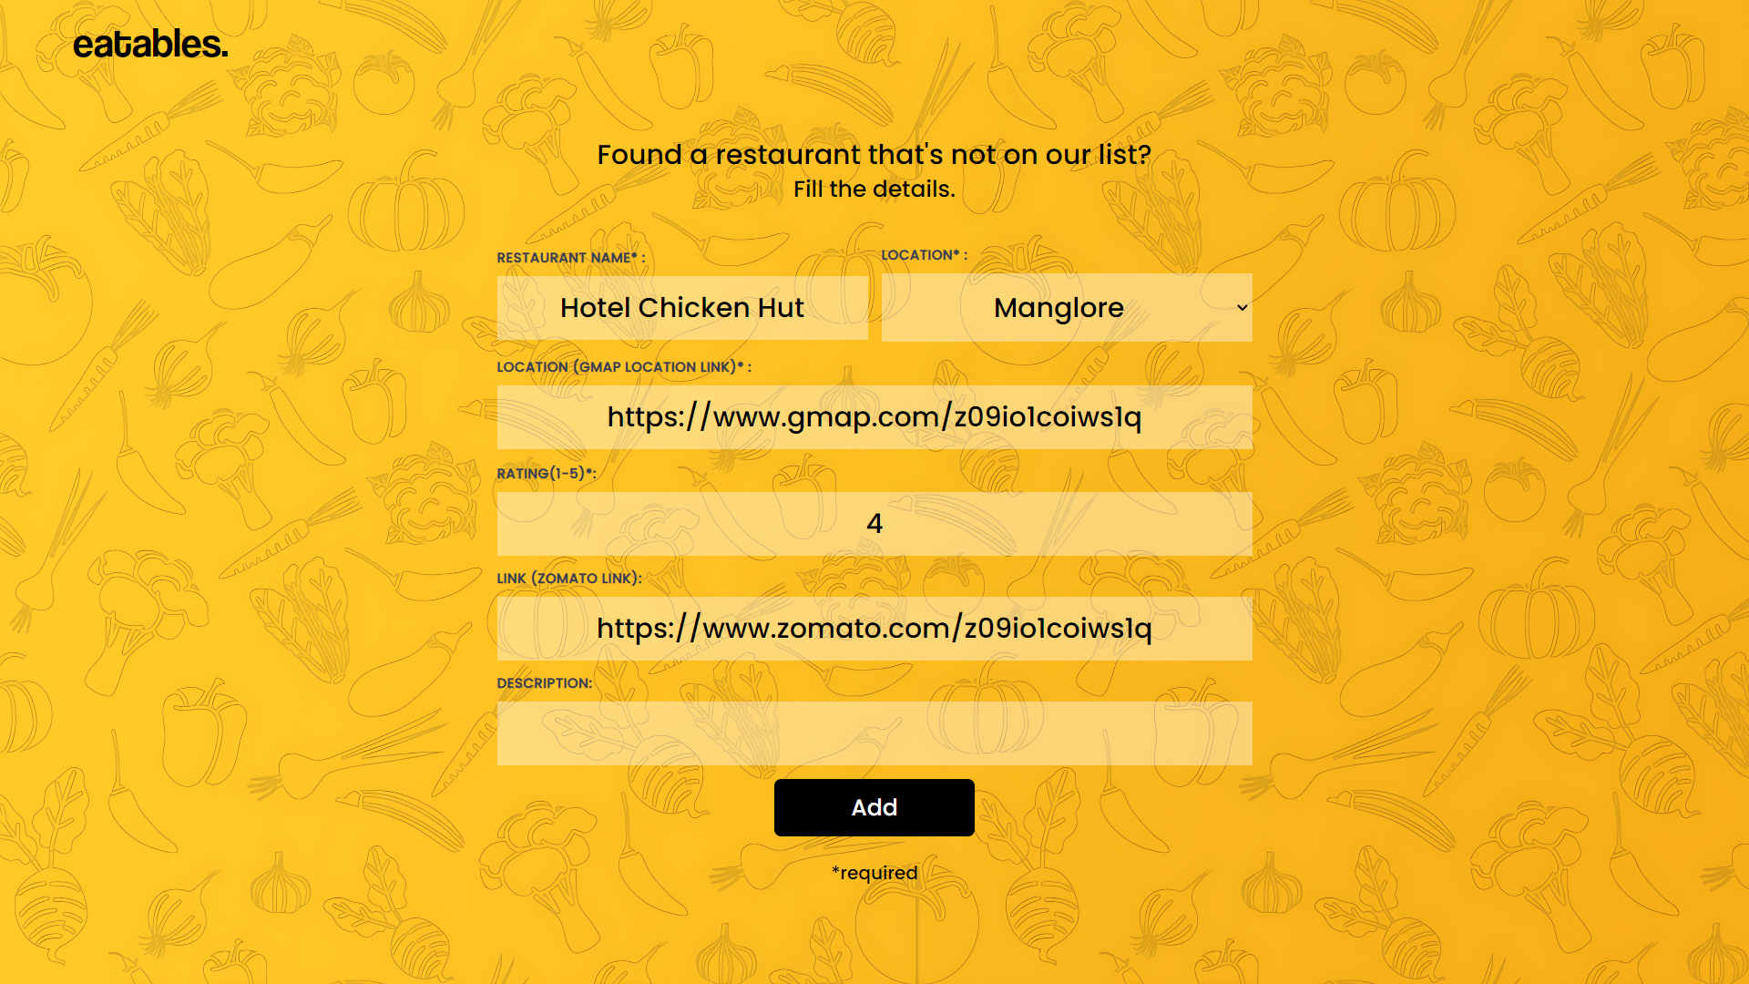

**4.3.4 Submit restaurant:**

|  |  |  |  |
| --- | --- | --- | --- |
| **Test Case ID** | **Test Condition** | **Expected Output** | **Result** |
| 1 | If restaurant name field empty | Displays please fill out this field | Success |
| 2 | If location field empty | Displays please fill out this field | Success |
| 3 | If ratings field empty | Displays please fill out this field | Success |
| 4 | If link field empty | Displays please fill out this field | Success |
| 5 | If description field empty | Displays please fill out this field | Success |
| 6 | If all fields are valid | Displays submit message and redirects to user profile page | Success |

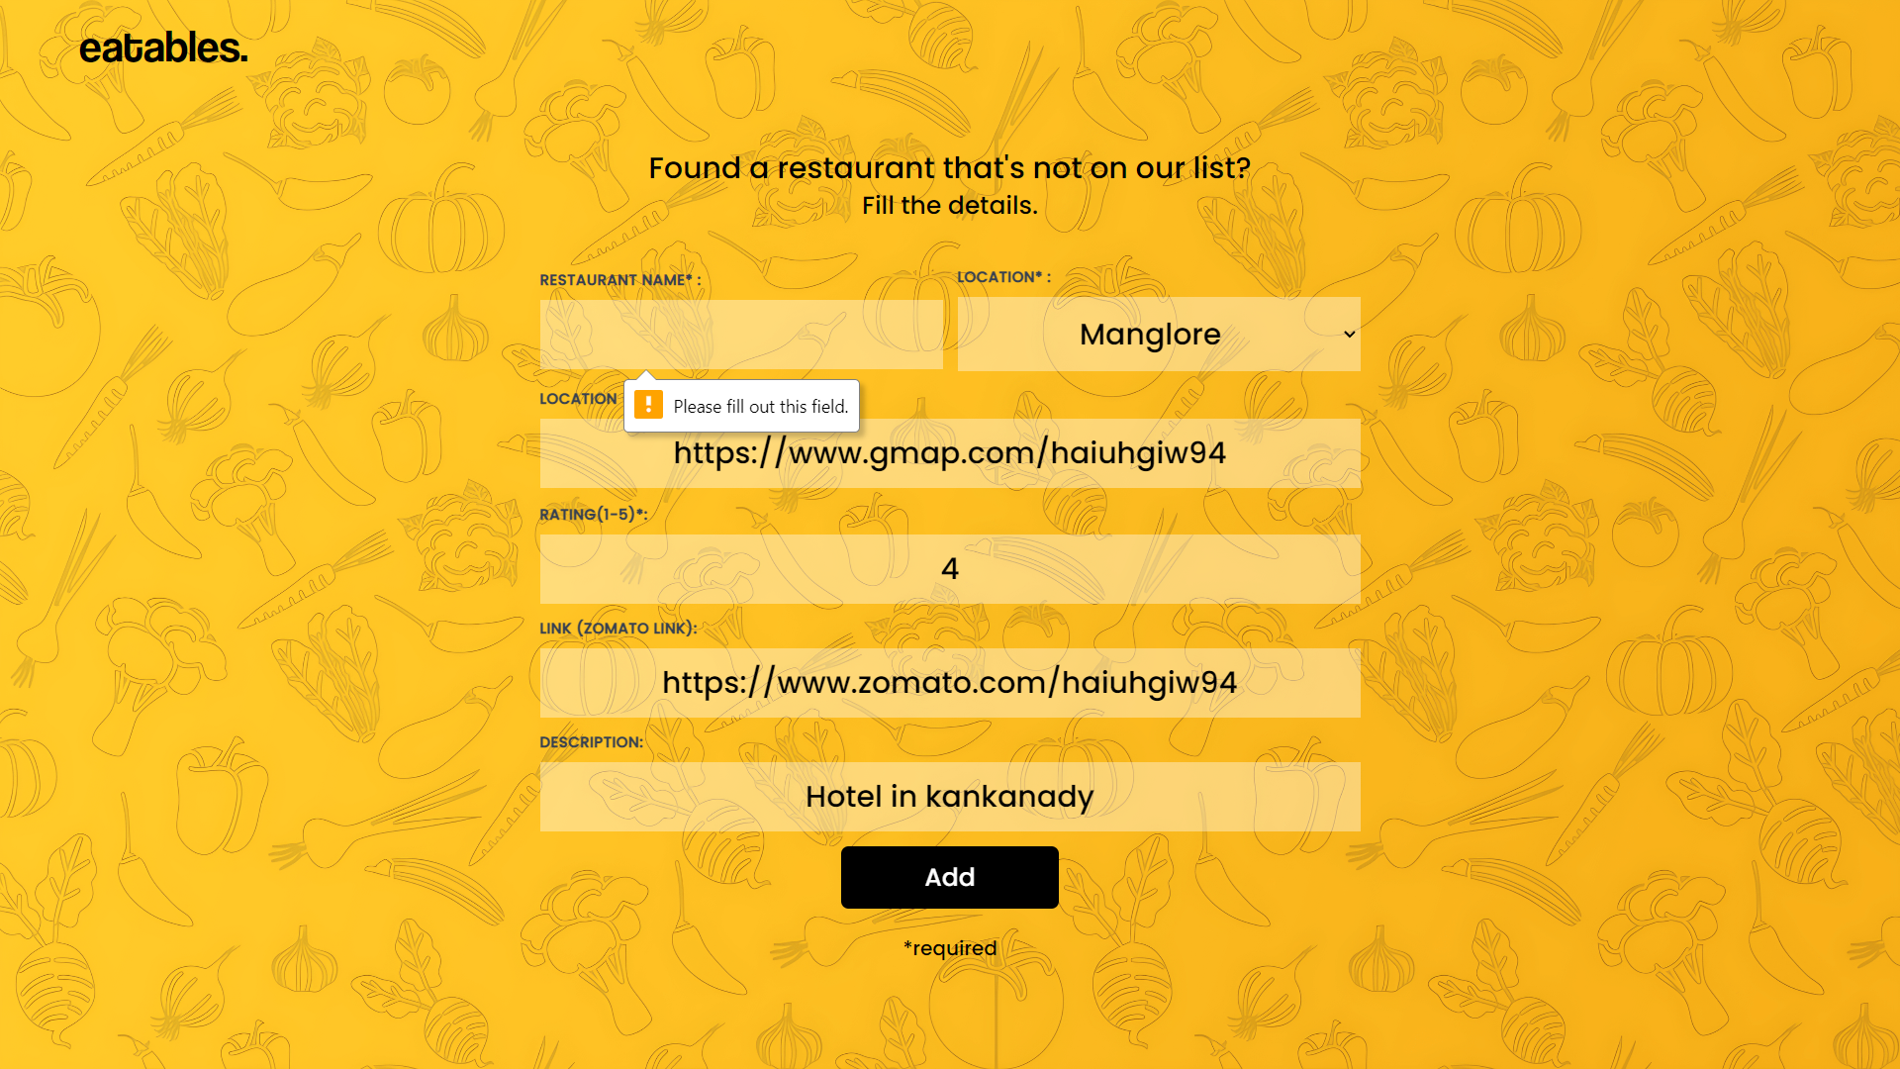

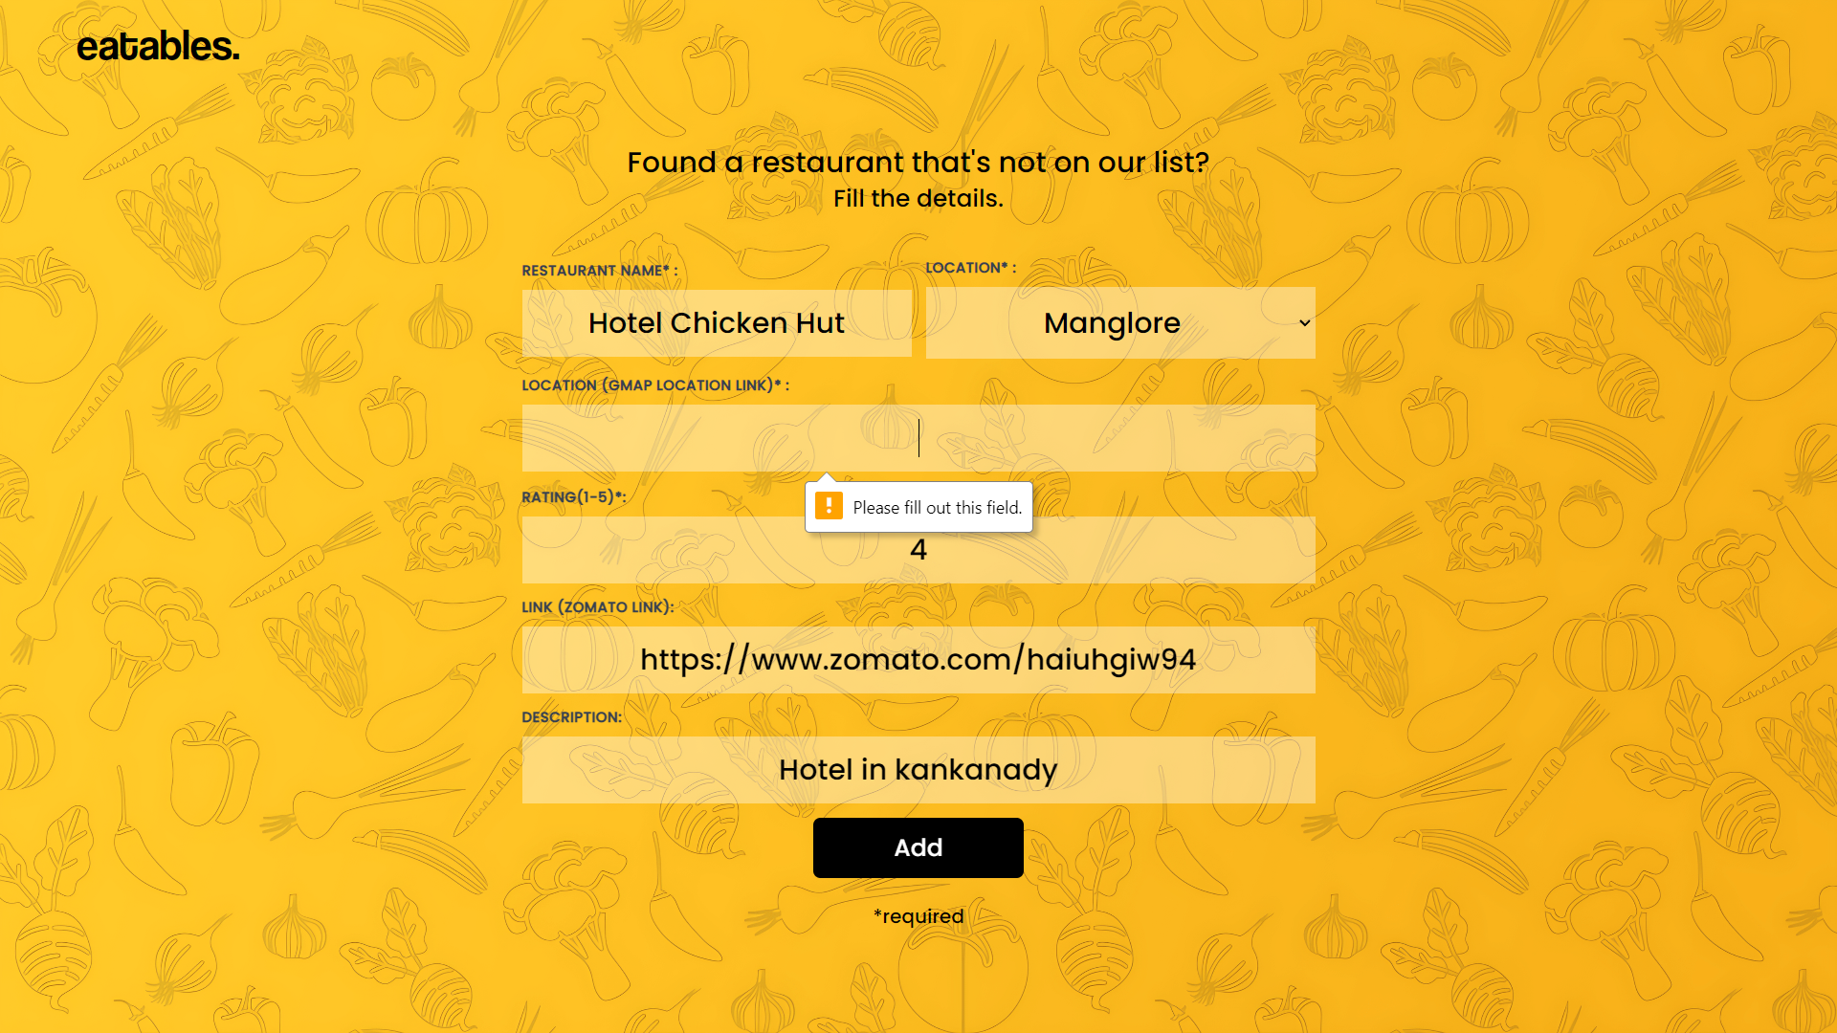

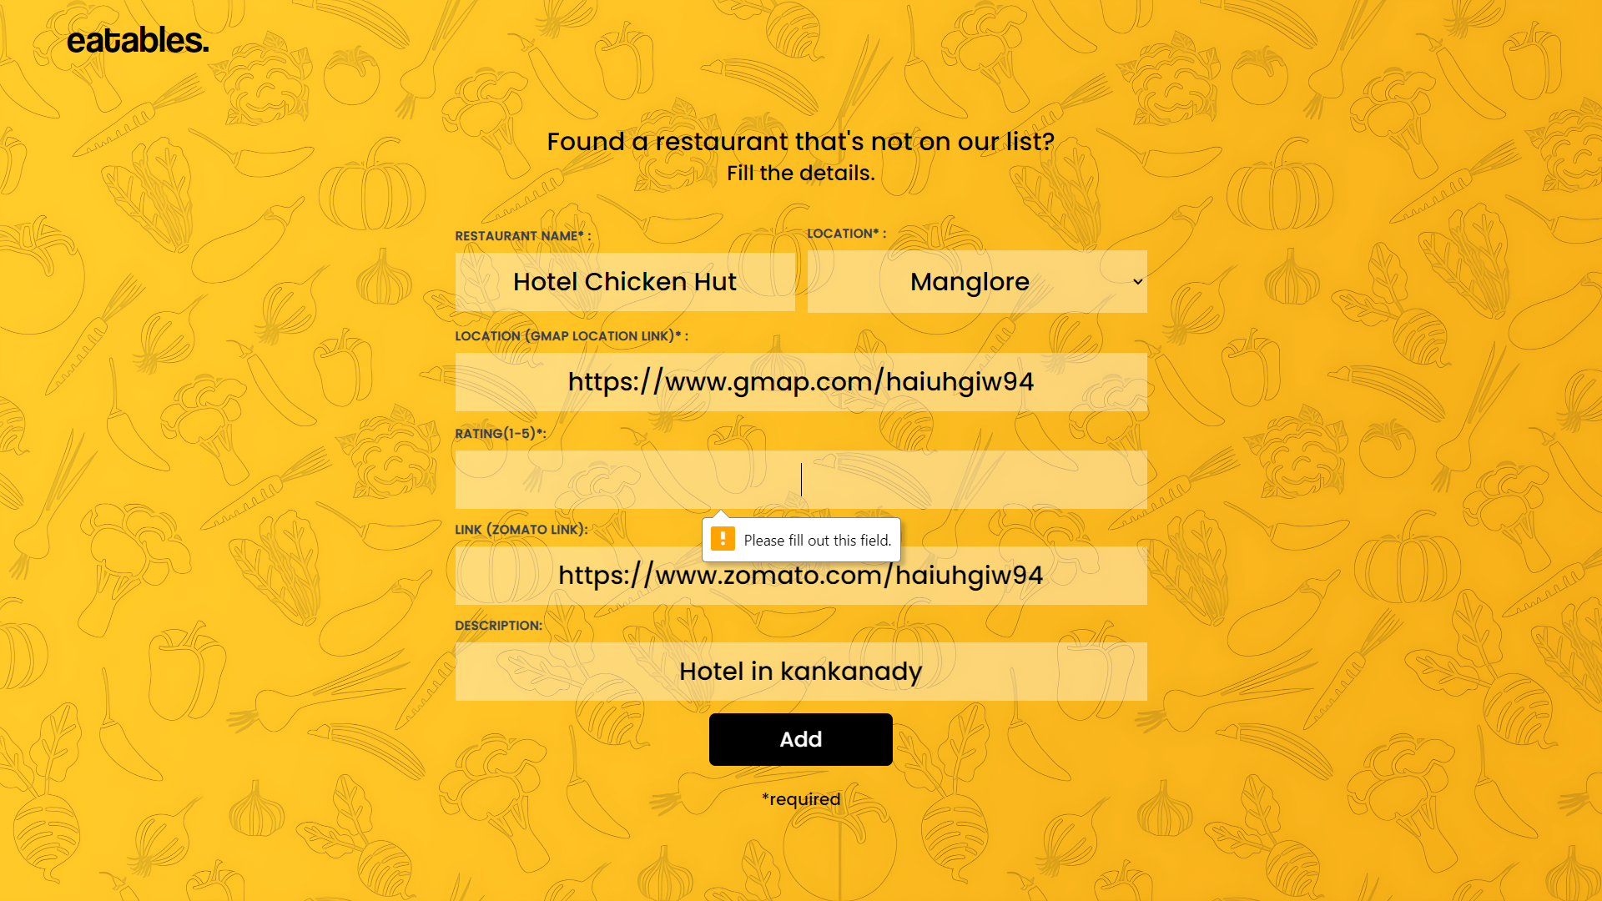

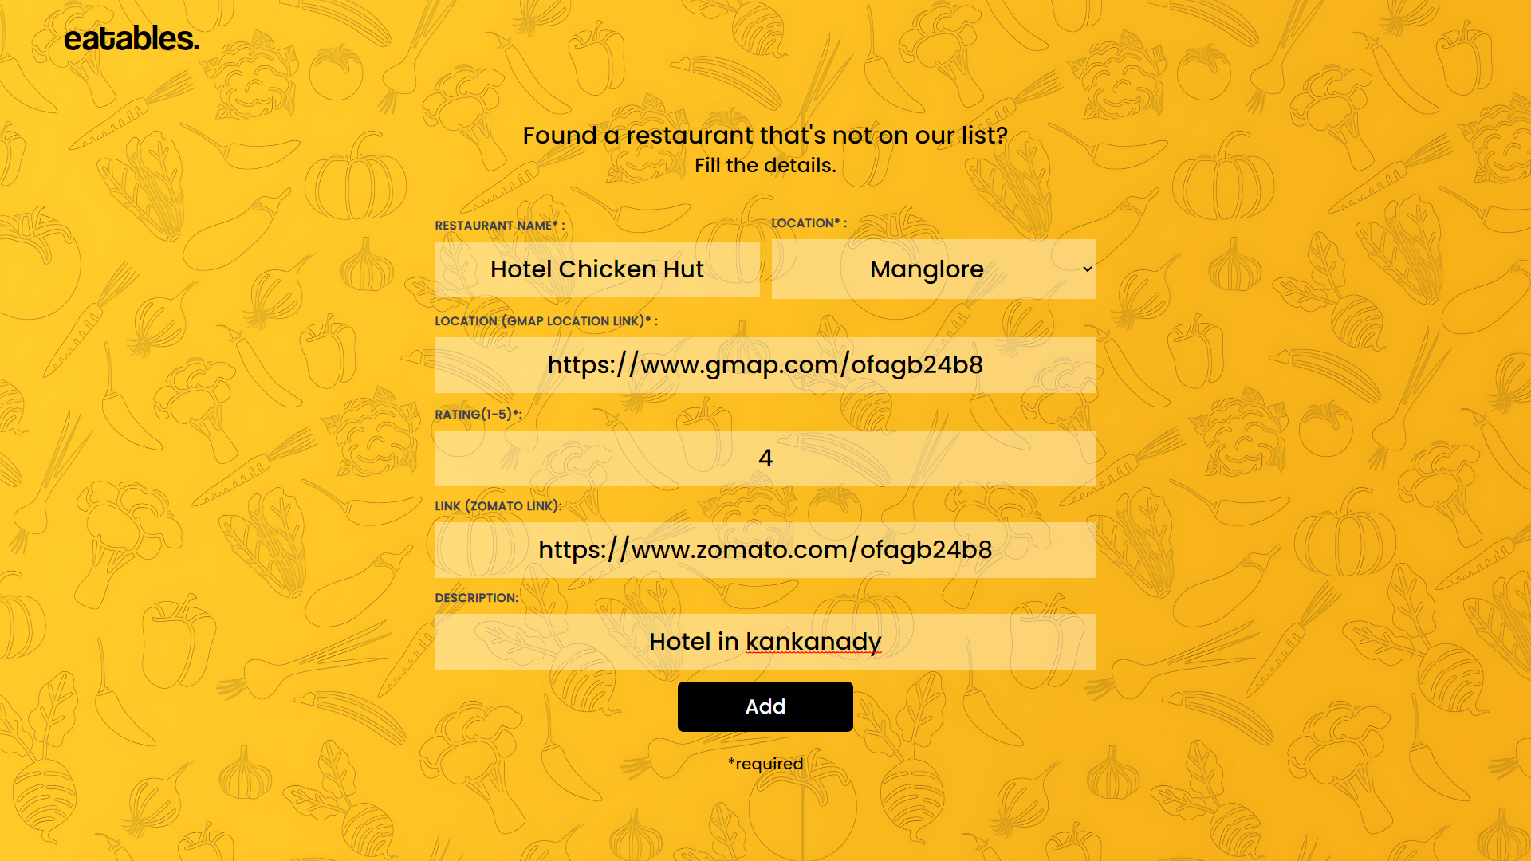

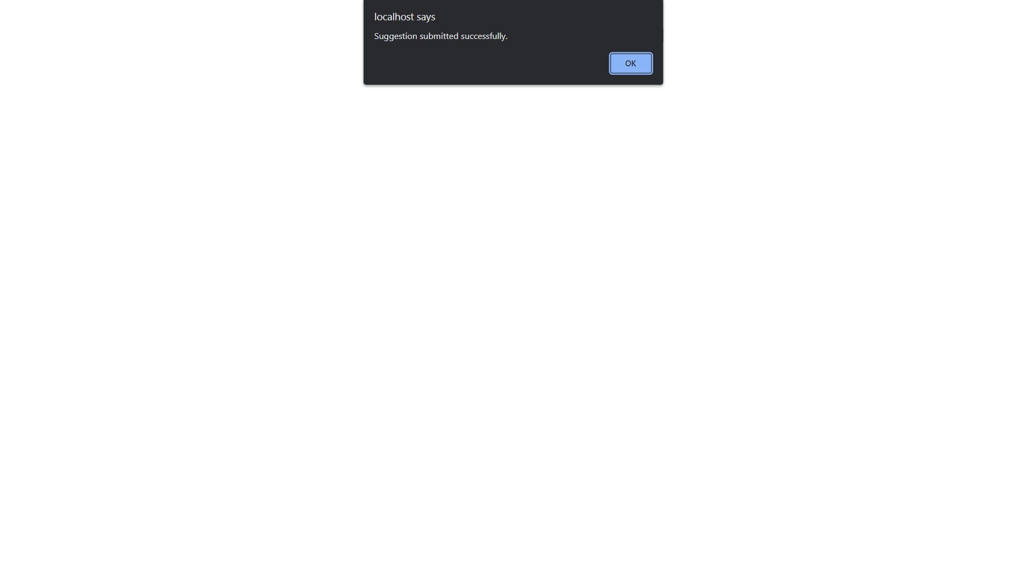

**4.3.5 Hotel page:**

|  |  |  |  |
| --- | --- | --- | --- |
| **Test Case ID** | **Test Condition** | **Expected Output** | **Result** |
| 1 | If user clicks on contact number | Dials the contact number | Success |
| 2 | If user clicks on email | Open gmail and compose a new mail | Success |
| 3 | If user clicks/drags on map | Shows location of the restaurant | Success |
| 4 | If user clicks on zomato icon | Redirects to zomato page of the restaurant | Success |
| 5 | If user clicks on an item | Redirects to item details page | Success |
| 6 | If user clicks on number in pagination | Redirects to the page | Success |
| 7 | If user clicks on eatables | Redirects to home page | Success |

Home page>>hotel page

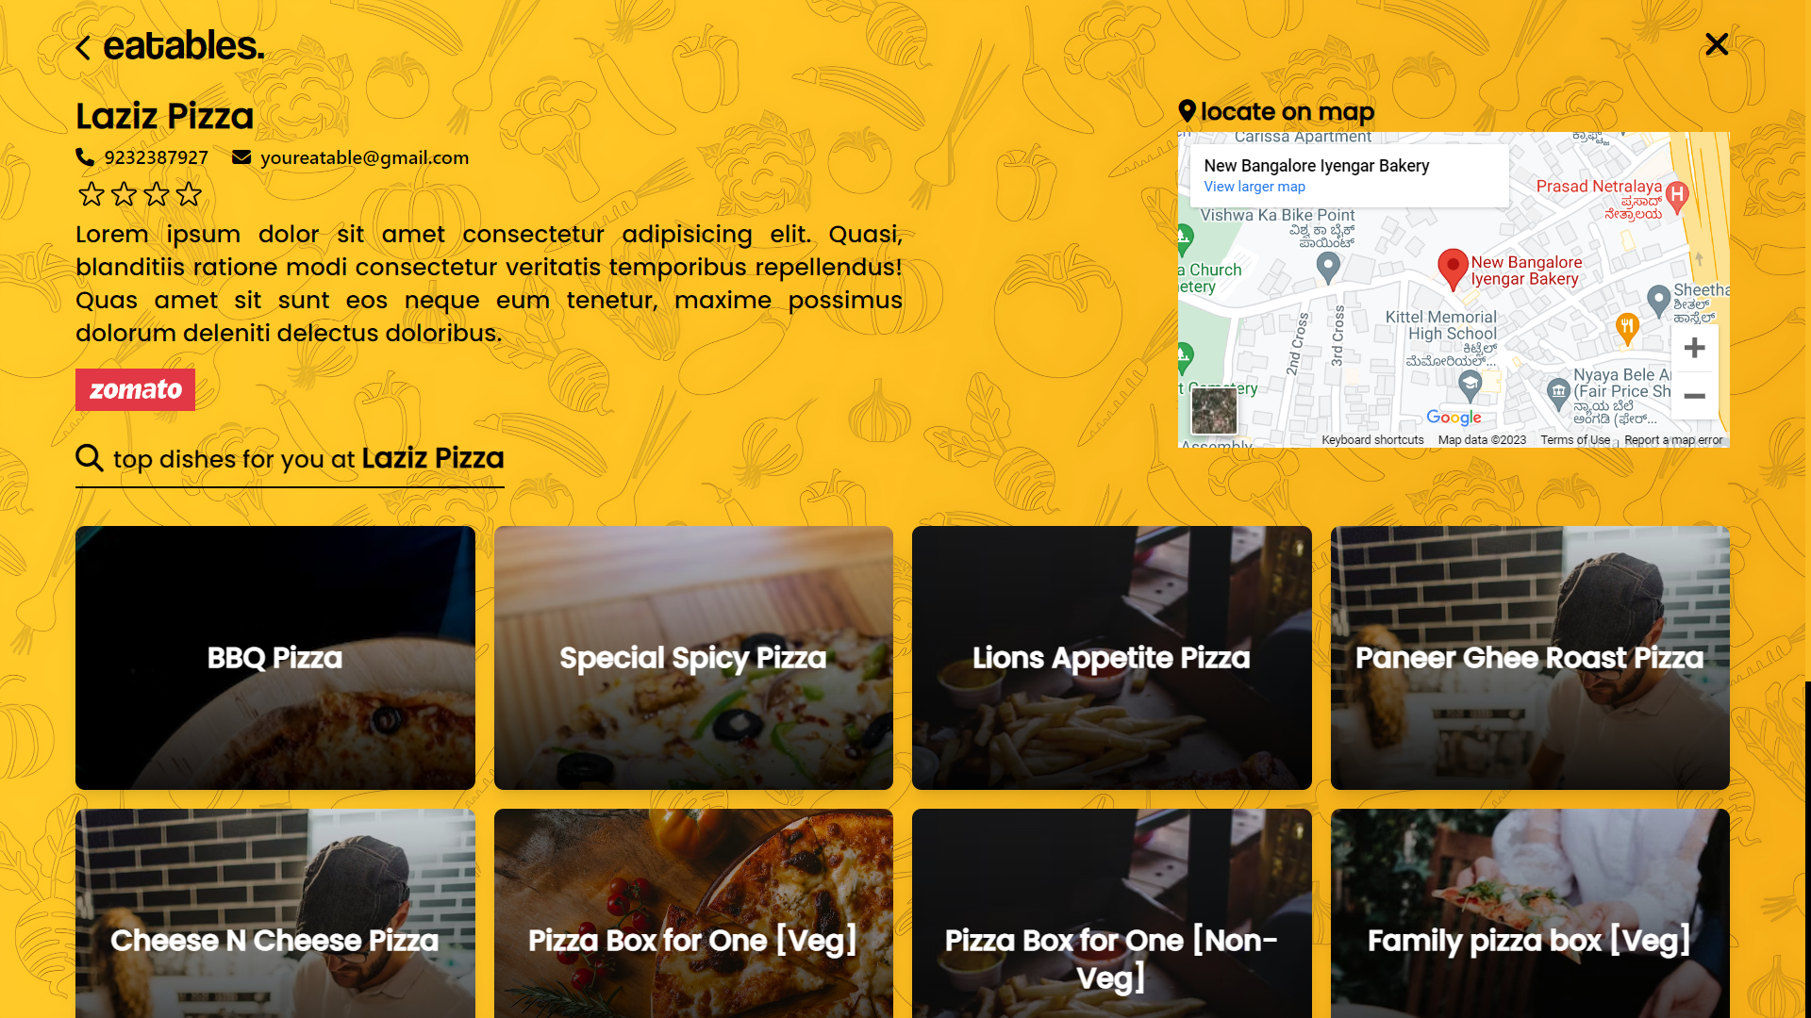

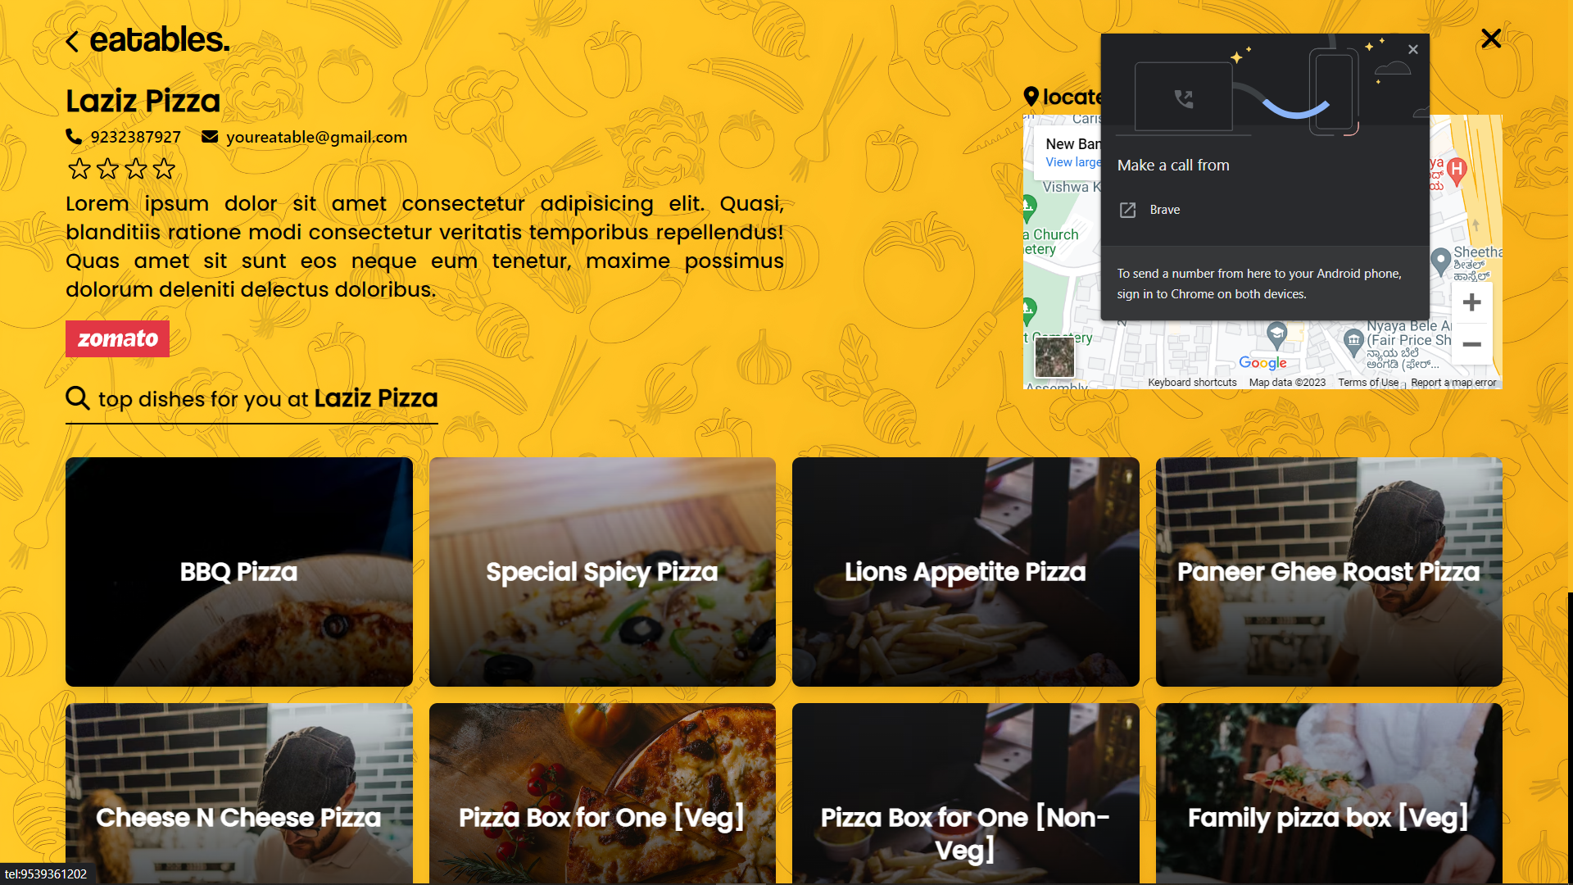

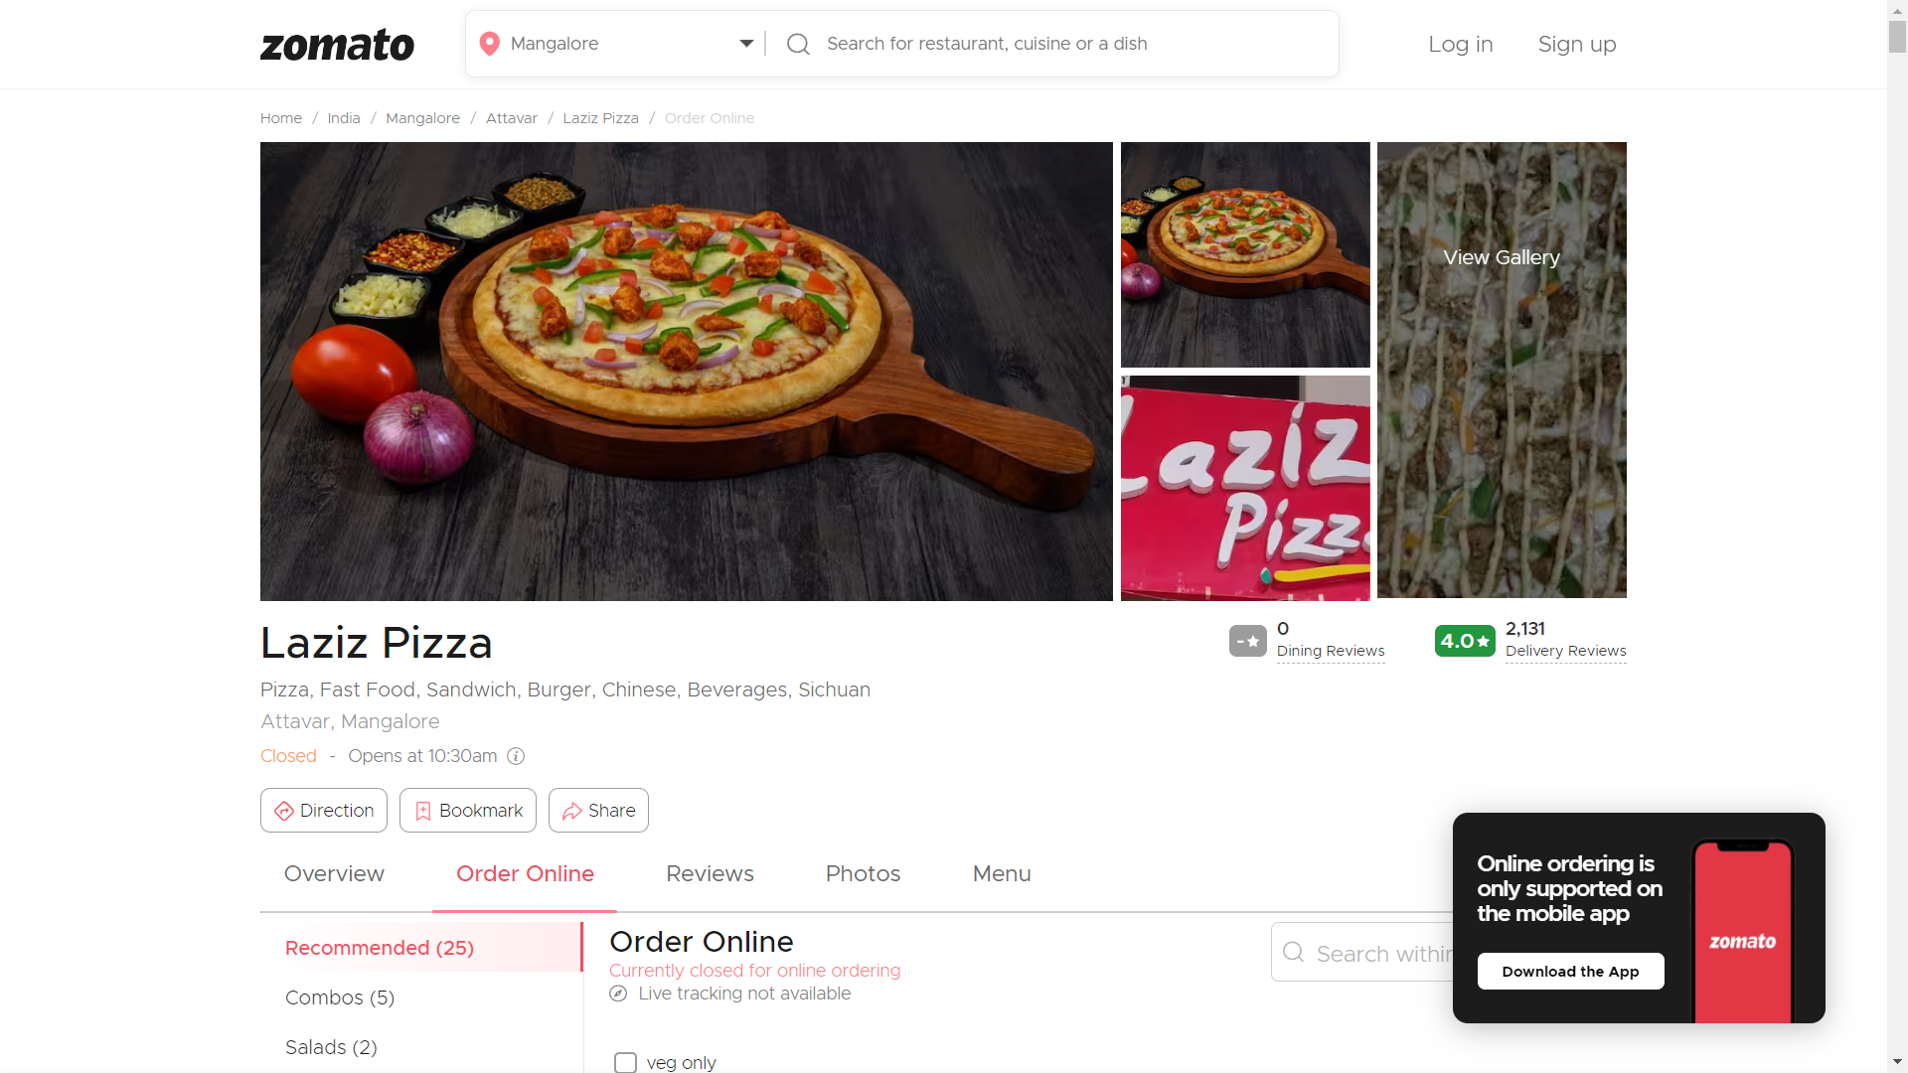

Hotel page>>item page:

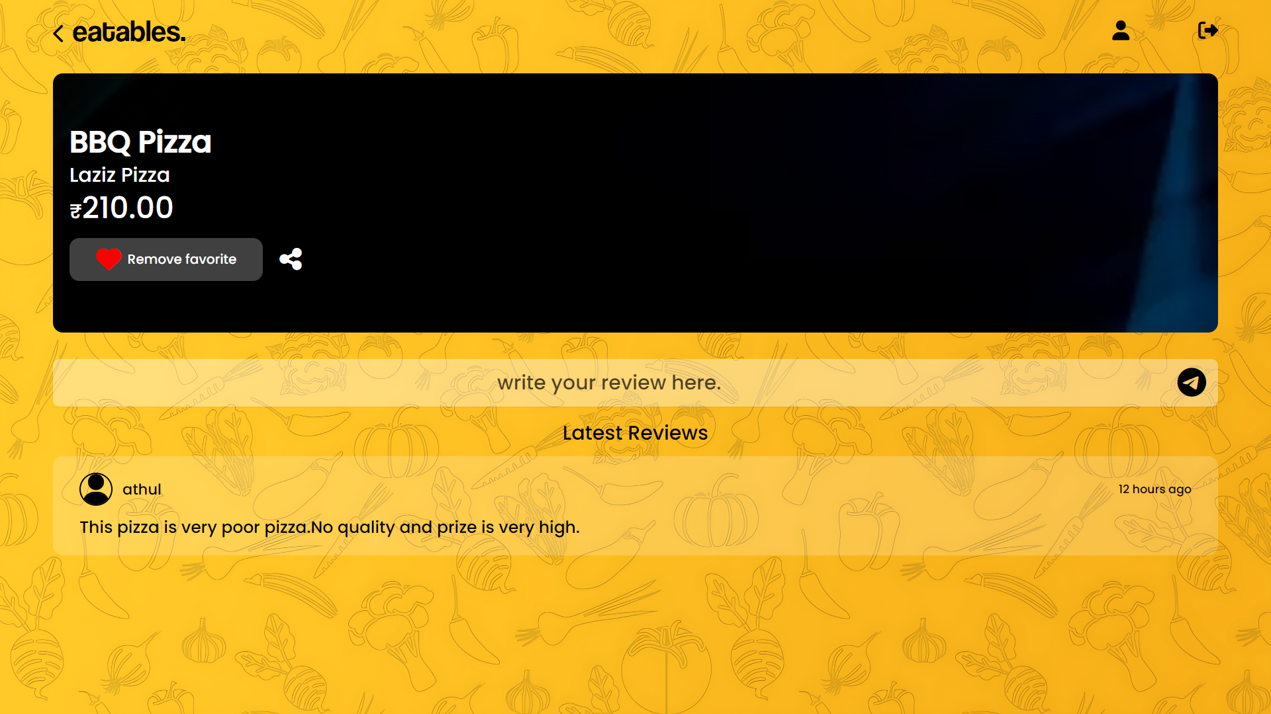

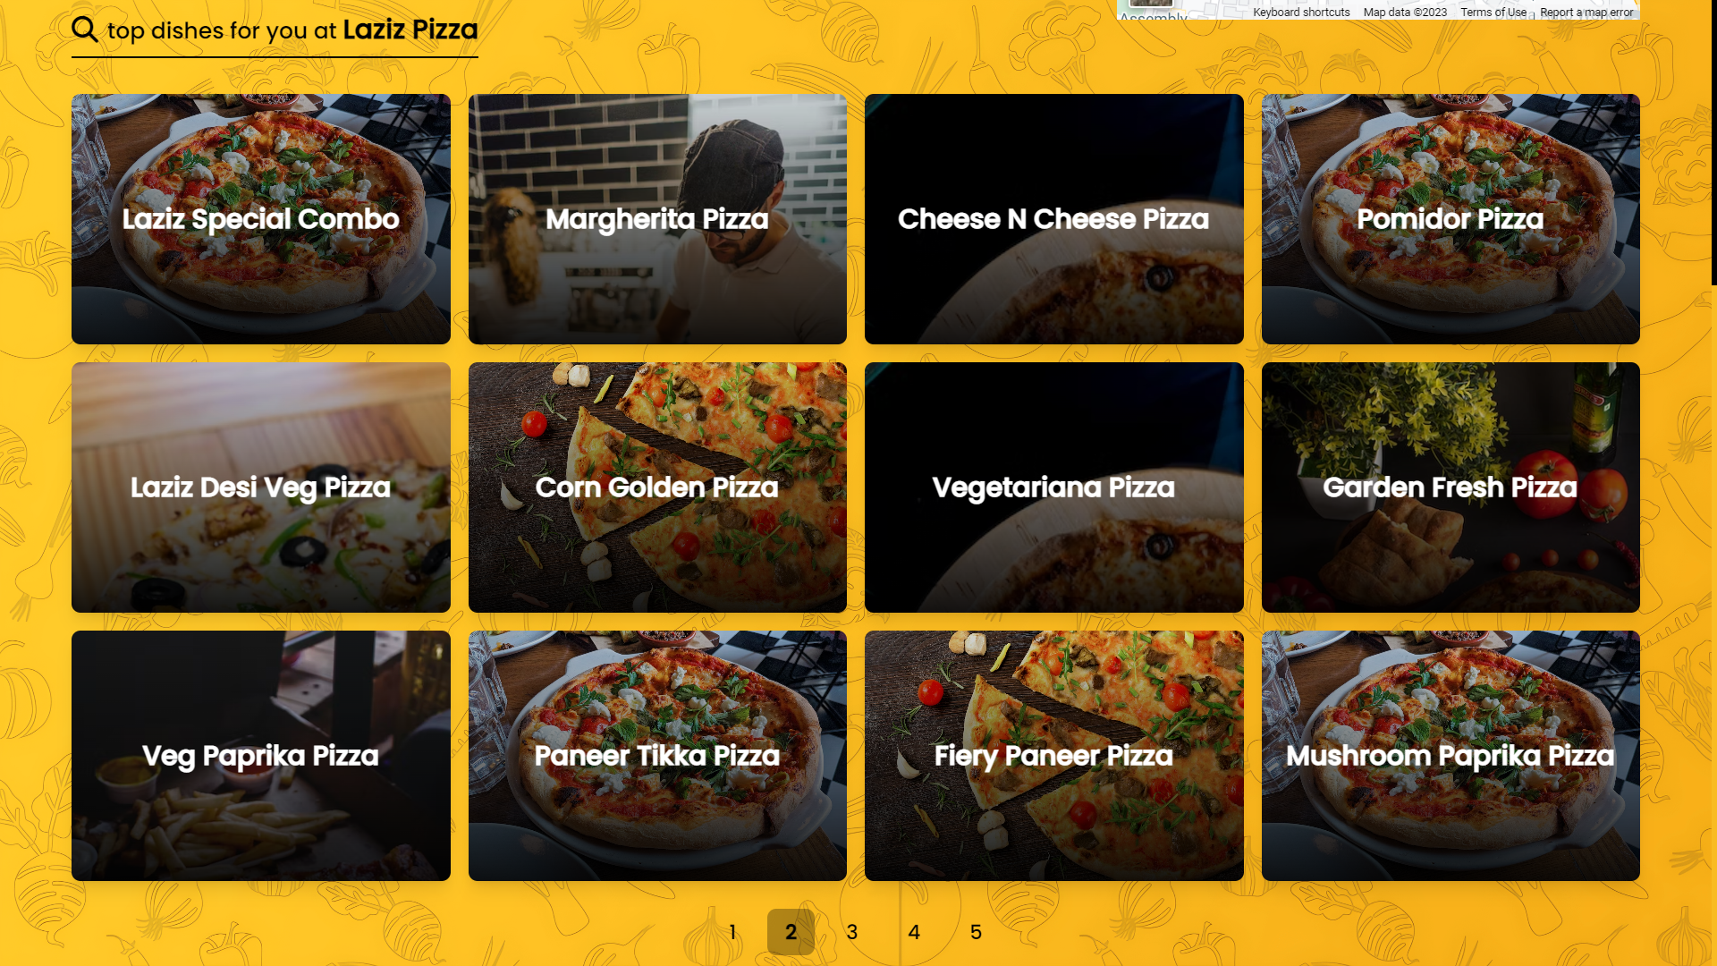

**4.3.6 Item page**

|  |  |  |  |
| --- | --- | --- | --- |
| **Test Case ID** | **Test Condition** | **Expected Output** | **Result** |
| 1 | If user clicks on eatables | Redirects to home page | Success |
| 2 | If user clicks on profile icon | Redirects to user profile page | Success |
| 3 | If user clicks on add to favourite/remove favourite | Item is added/removed from favourites accordingly | Success |
| 4 | If clicked on share icon | Website URL is copied to clipboard | Success |
| 5 | If tried to submit empty review | Displays please fill out this field | Success |
| 6 | If user submits review | Stores review and display it in the same page in the review section. | Success |
| 7 | If user clicks on logout icon | Log out and redirects to login page | Success |

Hotel page>>item page

